|  |
| --- |
|  |
| The Documentation |
| [Type the document subtitle] |
|  |
| **[Your Name]** |
| **[Pick the date]** |

[Type the abstract of the document here. The abstract is typically a short summary of the contents of the document. Type the abstract of the document here. The abstract is typically a short summary of the contents of the document.]

Table of Contents

[To update the table of contents, right click the message below and select Update Field (F9 on PC, ⌥⌘U on Mac).]

**No table of contents entries found.**

1. Pages
   1. Change Log
      1. User Interface

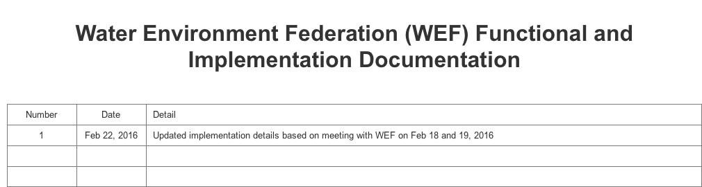

* 1. * Site Configuration
     1. User Interface

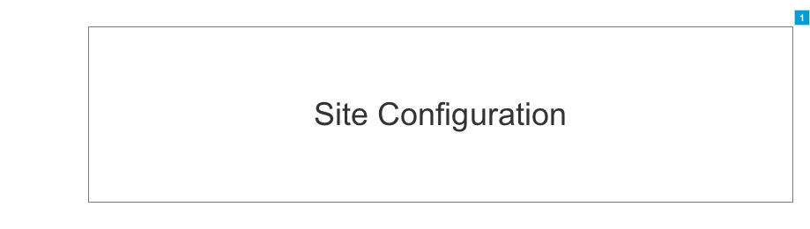

* + 1. Widget Table

|  |  |  |  |
| --- | --- | --- | --- |
| Footnote | Name | Functional Use Case | Implementation Guide |
| 1 | Site Configuration | The [site configuration] smart form contains global elements used site-wide. | ** The following [field name] (and type) are defined within the site configuration smart form: **  The following fields are contained within the [Header] section: 1) [Logo] (Image selector) 2) [Utility Nav Menu Id] (Text box) 3) [Social] (Repeater) - @@ NEED TO ASK WEF IF THERE IS A LIMIT @@  a) [Icon] (Icon selector)  b) [URL] (Hyperlink selector) 4) [Main Menu Id] (Text box) 5) [Search] (Text box)  The following fields are contained within the [Footer] section: 6) [Logo] (Image selector) 7) [Footer Menu Id] (Text box) 8) [Footer Links Menu Id] (Text box) 9) [Address] (Text box) 10) [Phone Number] (Text box) 11) [Social] (Repeater) - @@ NEED TO ASK WEF IF THERE IS A LIMIT @@  a) [Icon] (Icon selector)  b) [URL] (Hyperlink selector) 12) [Copyright] (Text box)   ** The following field name are defined within the app configuration setting: **  1) [Join/Log In] - This is a call to action button which redirects the user to a predefined login page. Logout logs the user out, redisplays the current page and update the link from 'Logout' to 'Join/Log In' 2) [Become a Member] - This is a call to action button which redirects the user to a predefined page. |

* 1. * Homepage
     1. User Interface

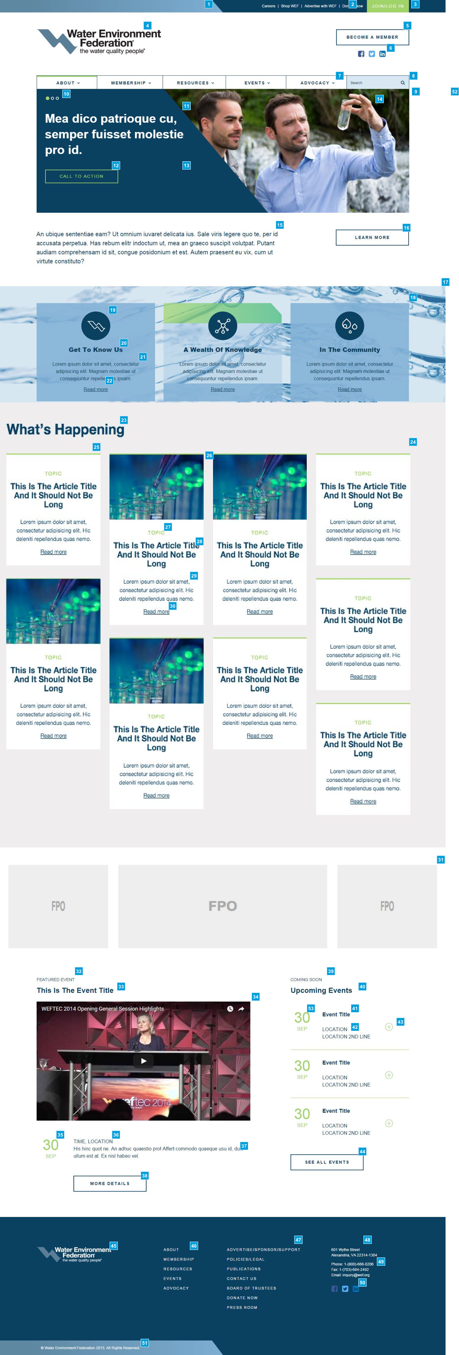

* + 1. Widget Table

|  |  |  |  |  |
| --- | --- | --- | --- | --- |
| Footnote | Name | Functional Use Case | Implementation Guide | Performance & Cache |
| 1 | Header: Utility Navigation Diagonal Separator | The dark blue/light blue diagonal separation is in a fixed position.  **On mobile, becomes a menu and the Join/Login button.** | Not applicable as this is handled as a front-end development effort. |  |
| 2 | Utility Navigation | An administrator should be able to manage the text of the utility navigation links and their destination pages: Careers, Shop WEF, Advertise with WEF, and Donate Now.   The number of links displayed in the utility navigation should be limited to no more than 4 links at any time. | This is to be managed via the site configuration smart form. |  |
| 3 | "Join/Log In" Call to Action Button | When a user clicks the "Log In" button, they should be taken to the "Log In" page (template 1.11). Once a user is logged in, the text on this button should change to "Log Out."   An administrator should be able to edit the text of this call to action button and its destination link. | This is to be managed via the site configuration smart form. |  |
| 4 | Logo | An administrator should be able to manage the logo.  NOTE: WEF expects to update their logo within 3-5 years. | This is to be managed via the site configuration smart form. |  |
| 5 | "Become a Member" Call to Action Button | When a user clicks the "Become a Member" call to action button, they should be taken to the "Log In" page, where they can begin the process of becoming a member.   @@ WEF - User should be taken to the 'Membership Join' workflow. It is assumed that this is the Personify New Membership Join page @@  Once a user has signed up successfully to become a member or has logged in as a member, the text on this button should change to "Welcome, [NAME]!" with a link to "View Profile" or "Renew Now," depending on the member's status in Personify.   @@ If the member has a renewal, then how will they navigate to the profile page? @@  **On hover, button background becomes dark blue and text becomes light blue.**  An administrator should be able to edit the text of this call to action button and its destination link. | This is to be managed via the site configuration smart form. |  |
| 6 | Social Media Icons | A user should be able to click any of these social media icons and be taken to the corresponding social media landing page for WEF.  An administrator can manage, add, and remove icons as necessary, as well as their destination links.  Icons are centered beneath "Become a Member" button. | This is to be managed via the site configuration smart form. |  |
| 7 | Main Navigation | A user should be able to click on any of the main navigation links and open their corresponding dropdown menus. The secondary level menus are also dropdowns, and the tertiary levels are flyouts ** that are activated on click**.   On hover, menu button turns light blue and text becomes dark blue. When a user clicks on a nav item, the hover effect stays and the top green bar will move to show which tab is active  An administrator should be able to edit the text and destination pages of these main navigation links and the links in the corresponding dropdown menus. An administrator should not be able to add or subtract items from the navigation.  Dropdown navigation will be supplied in WEF's design comp. | This is to be managed via the site configuration smart form. |  |
| 8 | Search Text Box | A user should be able to enter a search term and either hit "Enter" on their keyboard or click the magnifying glass to execute their search and be taken to a search results page.  As user inputs text into Search field, the text will autocomplete. | This is to be managed via the site configuration smart form.  This is to be implemented via standard SOLR Search. Submitting the search criteria redirects the user to the 'Search Results' page. |  |
| 9 | Slider Smart Form | The [Slider] smart form contains elements used to construct the slider. | ** The following [field name] (and type) are defined within the slider smart form: **  1) [Slider] (Repeater)  a) [Slider Images Indicator] - automatically defined by repeater count  b) [Slider Text] (Text box)  c) [Slider CTA Link] (Hyperlink selector)  d) [Slider CTA Text] (Text box)  e) [Slider Background Solid Color] (Drop down with 2 options 'Navy with white text' (default) and 'Blue with navy text)  f) [Slider Image] (Image selector) |  |
| 10 | Slider Images Indicator | This element indicates the total number of images in the slider,and which image the slider is currently featuring.  This (5) is the maximum number of slides allowed. If there is only one slide, no indicator will show. | This is to be managed via the slider smart form. |  |
| 11 | Slider Text | The maximum amount of copy for this slider text is 55 characters. | This is to be managed via the slider smart form. |  |
| 12 | Slider CTA | A user should be able to hover over this call to action button and the button will fill with reversed out type and expand to show an arrow icon. Clicking on this call to action button will take the user to its corresponding interior page.  @@ Can this be configured to redirect the user to a redirection link (external page)? @@  On hover it will appear green  An administrator should be able to edit the text of this call to action button and its destination link. | This is to be managed via the slider smart form. |  |
| 13 | Slider Background Solid Colors | There should be two background options for the slider:  1. This version (Navy with white text) 2. Blue with Navy text | This is to be managed via the slider smart form. |  |
| 14 | Slider Images | Must be rectangular and fill container. Navy overlay moves underneath image on mobile. | This is to be managed via the slider smart form. |  |
| 15 | Slider Copy Text | An administrator should be able to manage this text.  The text should have a limited number of characters. Three lines should be the max. | This is to be managed via the homepage smart form. |  |
| 16 | Slider Copy CTA | An administrator should be able to edit the text of this CTA button and its destination link.  **On hover, button background becomes dark blue and text becomes light blue.** | This is to be managed via the homepage smart form. |  |
| 17 | Background Image | This image does not need to be managed. It stays fixed with a scrolling parallel effect. The positioning is higher or lower based on the template. Please see mark-up. | Not applicable as this is handled as a front-end development effort. | N/A |
| 18 | Featured Card Smart Form | The [featured card] smart form contains elements used to construct the featured card.  The sort order will be from left to right then top to bottom. So, the first card is the upper leftmost and the second card is immediately to the right. Cards sorted manually (defined by WEF admin) On hover, the card is displayed with a green overlay and the upper right corner is 'folded'  Homepage - There will always be three (3) featured content cards in a single row. Landing page - There is no max number of featured content cards and there may be more than one row defined. | ** The following [field name] (and type) are defined within the featured card smart form: **  1) [Featured card] (Repeater)  a) [Featured Card Icon] (Image selector)  b) [Featured Card Headline] (Text box)  c) [Featured Card Teaser] (Text box)  c) [Feature Card CTA Link] (Hyperlink selector)  d) [Feature Card CTA Text] (Text box) |  |
| 19 | Featured Card Icon | An administrator should be able to edit these icons, which can be chosen from the provided icons, or WEF can add their own icons if they need to.  If the image is not configured, then this space is collapsed and the headline, description and call to action is shifted up. | This is to be managed via the featured card smart form.  Note: The feature card icon is only defined for the homepage and not defined for the landing page. |  |
| 20 | Featured Card Headline | An administrator should be able to edit this text. | This is to be managed via the featured card smart form. |  |
| 21 | Featured Card Teaser | An administrator should be able to edit this text.  The max number of lines is 3. If content is less, box remains the same height. | This is to be managed via the featured card smart form. |  |
| 22 | Feature Card CTA | This is an anchor for a link and does not change.   An administrator should be able to manage the destination link. | This is to be managed via the featured card smart form. |  |
| 23 | What's Happening Headline | An administrator should be able to edit this text. | This is to be managed via the homepage smart form. |  |
| 24 | What's Happening Card Smart Form | The [what's happening card] smart form contains elements used to construct the what's happening card.  The layout will be 4x3, where sort order will be from left to right then top to bottom. So, the first card is the upper leftmost and the second card is immediately to the right. Cards sorted manually (defined by WEF admin) On hover, the card is displayed with a green overlay This content can be manually controlled by an administrator. | ** The following [field name] (and type) are defined within the what's happening card smart form: **  1) [What's happening card] (Repeater)  a) [Card Image] (Image selector)  b) [Card Topic] (Text box)  c) [Card Headline] (Text box) - No limit on the character count. Text should be defaulted based on the content id selected. Then it should allow the admin to update the text.  d) [Card Teaser] (Text box) - No limit on the character count. Text should be defaulted based on the content id's summary tab. Then it should allow the admin to update the text.  e) [Card CTA Link] (Content selector) - This should be the first selected field. After selection, it auto-populates the card CTA link, card headline and card teaser.  f) [Card CTA Text] (Text box)   Note: all fields are mandatory except for the card image |  |
| 25 | Card Color Bar | This color bar is always the same on all cards in this section. | Not applicable as this is handled as a front-end development effort. | N/A |
| 26 | Card Image | Images are not necessary on all posts.The image is not unique to this usage and will display at larger dimensions on associated page.  An administrator should be able to insert/edit this image.  Note: no video may be displayed (only images) | This is to be managed via the what's happening card smart form. |  |
| 27 | Card Topic | This "Topic" label is a way to categorize content.   An administrator should be able to edit this text/these labels. If multiple topics are defined for this content item, then the administrator shoud be able to flag the topic to be displayed on this page. | This is to be managed via the what's happening card smart form. |  |
| 28 | Card Headline | An administrator should be able to edit this headline.   Note: The card headline may be different then the actual content headline that will be displayed on the redirected page. | This is to be managed via the what's happening card smart form. |  |
| 29 | Card Teaser | An administrator should be able to manage this text. | This is to be managed via the what's happening card smart form. |  |
| 30 | Card CTA | This is an anchor for a link and does not change.   An administrator should be able to manage the destination link. | This is to be managed via the what's happening card smart form. |  |
| 31 | Ad Deck | WEF to implement using Ban Man Pro. | This is to be managed via the homepage card smart form. |  |
| 32 | Featured Event Title | An administrator should not be able to edit this text. | This is automatically defined within the control. |  |
| 33 | Featured Event Headline | An administrator should be able to edit this text. | This is to be managed via the homepage card smart form. |  |
| 34 | Featured Event Image | An administrator can add video or image content. Video will play in frame.  If neither of these are applicable, this content block will not display and the content below will fold below the event title. | This is to be managed via the homepage card smart form. |  |
| 35 | Featured Event Date Text | An administrator should be able to edit this text. | This is to be managed via the homepage card smart form. |  |
| 36 | Featured Event Time Location Text | Any type of content can go here: City, Building, Country, etc.  An administrator should be able to edit this text. | This is to be managed via the homepage card smart form. |  |
| 37 | Featured Event Teaser | This is teaser copy to introduce an event. An administrator should be able to edit this text.  Recommended: This is the max amount of copy that should go here (no more than 3 lines). | This is to be managed via the homepage card smart form. |  |
| 38 | Featured Event CTA | **On hover, button background becomes dark blue and text becomes light blue.**  An administrator should be able to edit the text of this call to action button and its destination link. | This is to be managed via the homepage card smart form. |  |
| 39 | Coming Soon Event Title | An administrator should not be able to edit this text. | This is automatically defined within the control. |  |
| 40 | Coming Soon Event Headline | Headline does not change.  Events are dynamically managed. Max number of events to display is three (3). Display events that are closest to the current date (based on the start date), but bypass the featured event from the coming soon section if it is detected in the list. | This is automatically defined within the control. |  |
| 41 | Coming Soon Event Headline | The Event Title can go to multiple lines; if so, the individual section height will increase.  An administrator should be able to edit this text. | This is to be managed via the homepage card smart form. |  |
| 42 | Coming Soon Event Location Text | An administrator should be able to edit this text. | This is to be managed via the homepage card smart form. |  |
| 43 | Coming Soon Event Detail CTA | This CTA is also used to expand content in the Event - Detail page. | This is to be managed via the homepage card smart form. |  |
| 44 | Coming Soon See All Events CTA | **On hover, button background becomes dark blue and text becomes light blue.**  An administrator should be able to edit the text of this call to action button and its destination link. | This is to be managed via the homepage card smart form. |  |
| 45 | WEF Logo: Footer | An administrator should be able to manage this logo. | The Individual Content Component will be the data source which an admin will select to populate the Master Configuration, which is displayed in all Layouts. |  |
| 46 | Footer Main Navigation Links | These links are repeated from the main navigation.  An administrator can change links' names and destinations, but links can not be added or deleted. | This is to be managed via the Menu Hierarchy. |  |
| 47 | Footer Links | An administrator should be able to add significant links to this section (limited to 10 links). An administrator should also be able to edit the text and destination of these links. | This is to be managed via the Menu Hierarchy. |  |
| 48 | Footer: WEF Address | A user should be able to click this address text and be taken to its link on a Google Map. The link should open in a new browser tab or window (depending on the user’s browser preferences).  An administrator should be able to edit this text and the destination link. | The Individual Content Component will be the data source which an admin will select to populate the Master Configuration, which is displayed in all Layouts. |  |
| 49 | Footer: Phone Number | On mobile, this number should be a link. | The Individual Content Component will be the data source which an admin will select to populate the Master Configuration, which is displayed in all Layouts. |  |
| 50 | Footer Social Media Icons | As in the header, the user should be able to click any of these social media icons and be taken to the corresponding social media landing page for WEF.   An administrator can manage, add, and remove icons as necessary, as well as their destination links. These should be controlled in one place.  These icons should be flush left. | This is to be managed via the Menu Hierarchy. |  |
| 51 | WEF Copyright: Footer | An administrator should be able to manage this text. | The Individual Content Component will be the data source which an admin will select to populate the Master Configuration, which is displayed in all Layouts. |  |
| 52 | Homepage Smart Form | The [homepage] smart form contains elements used to construct the homepage. | ** The following [field name] (and type) are defined within the homepage smart form: **  The following fields are contained within the [Main Hero] section: 1) [Slider] (Content selector) 2) [Slider Copy Text] (Text box) 3) [Slider Copy CTA Link] (Hyperlink selector) 4) [Slider Copy CTA Text] (Text box)  The following fields are contained within the [Card] section: 5) [Featured Card] (Content selector) 6) [What's Happening Headline] (Text box) 7) [What's Happening Card] (Content selector) 8) [Ad Card] (Text box) - VINCENT - need to ask Tanuj how this will be managed?  The following fields are contained within the [Featured Event] section: 9) [Featured Event] (Content selector) 10) Featured Event Headline - Automatically defined when featured event selected. 11) Featured Event Image - Automatically defined when featured event selected. 12) Featured Event Date Text - Automatically defined when featured event selected. 13) Featured Event Time Location Text - Automatically defined when featured event selected. 14) Featured Event Teaser - Automatically defined when featured event selected. 15) Featured Event CTA Link - Automatically defined when featured event selected. 16) [Featured Event CTA Text] (Text box)    The following fields are contained within the [Coming Soon] section: 17) [Coming Soon Events] (Repeater)  a) [Coming Soon Event] (Content selector)  b) Coming Soon Event Date Text - Automatically defined when coming soon event selected.  c) Coming Soon Event Headline - Automatically defined when coming soon event selected.  d) Coming Soon Event Location Text - Automatically defined when coming soon event selected.  e) Coming Soon Event Detail CTA Link - Automatically defined when coming soon event selected.  f) [Coming Soon See All Events CTA Link] (Hyperlink selector)  g) [Coming Soon See All Events CTA Text] (Text box) |  |
| 53 | Coming Soon Event Date Text | An administrator should be able to edit this text. | This is to be managed via the homepage card smart form. |  |

* 1. Mobile Homepage
     1. User Interface



* + 1. Widget Table

|  |  |  |
| --- | --- | --- |
| Footnote | Name | Functional Use Case |
| 1 | Mobile Main Menu Button | A user should be able to touch this button and the mobile menu will fill the screen. Design provided separately. |
| 2 | Main Slider CTA Button: Mobile | Clicking on this call to action button will take the user to its corresponding interior page.  An administrator should be able to edit the text of this call to action button and its destination link. |
| 3 | What's Happening Content Block: Mobile | Only the 3 most recent articles will display on mobile. |
| 4 | Ad Space: Mobile | Only the first ad from the browser layout will display in mobile. |
| 5 | Featured Event Video: Mobile | When a user taps the video, the video will play in the native mobile player. |
| 6 | Upcoming Events: Mobile | On mobile, only the 3 most recent Upcoming Events will display. |
| 7 | Mobile Footer | This is a simplified footer; no main navigation or secondary links will display.  @@ Up to 10 footer links can be configured by admin?? @@ |

* 1. * Landing
     1. User Interface

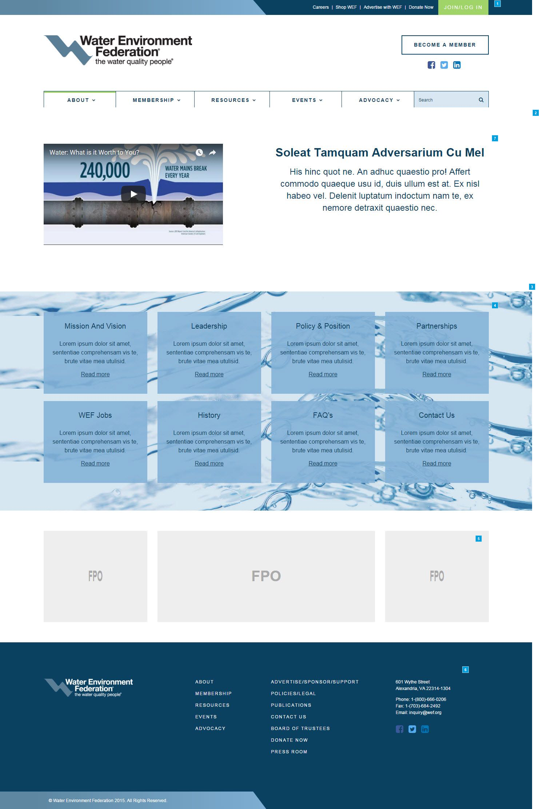

* + 1. Widget Table

|  |  |  |  |  |
| --- | --- | --- | --- | --- |
| Footnote | Name | Functional Use Case | Implementation Guide | Performance & Cache |
| 1 | Header and Main Navigation | These elements have the same functionality as indicated in the notes for widgets 1.3.1-8 on the Homepage (Template 1.3). | Please see Implementation Guide for widgets 1.3.1-8 on the Homepage. |  |
| 2 | Landing Page Smart Form | The [landing page] smart form contains elements used to construct the landing page. | ** The following [field name] (and type) are defined within the landing page smart form: **  The following fields are contained within the [Main Hero] section: 1) [Subheader] (Content selector / Subheader smart form) - Please see Implementation Guide for widgets 1.9.2-7 on the Leadership page.  The following fields are contained within the [Card] section: 2) [Featured Card] (Content selector / Featured card smart form) - Please see Implementation Guide for widgets 1.3.18-22 on the Homepage. 3) [Ad Card] (Text box) - VINCENT - need to ask Tanuj how this will be managed? |  |
| 3 | Background Image | This image does not need to be managed. It stays fixed with a scrolling parallel effect. The positioning is higher or lower based on the template. Please see mark-up. | Not applicable as this is handled as a front-end development effort. | N/A |
| 4 | Featured Card Smart Form | This element has the same functionality as indicated in the notes for widgets 1.3.18-23 on the Homepage (Template 1.3).  Note: The feature card icon is not defined for the landing page. | This is to be managed via the landing page smart form.  Please see Implementation Guide for widgets 1.3.18-22 on the Homepage. |  |
| 5 | Ad Deck | WEF to implement using Ban Man Pro. | This is to be managed via the landing page smart form. |  |
| 6 | Footer | This element has the same functionality as indicated in the notes for widgets 1.3.45-51 on the Home Page (Template 1.3). | Please see Implementation Guide for widgets 1.3.45-51 on the Homepage. |  |
| 7 | Subheader | This element has the same functionality as indicated in the notes for widgets 1.9.2-7 on the Leadership page (Template 1.9). | This is to be managed via the landing page smart form.  Please see Implementation Guide for widgets 1.9.2-7 on the Leadership page. |  |

* 1. Mobile Landing
     1. User Interface



* + 1. Widget Table

|  |  |  |
| --- | --- | --- |
| Footnote | Name | Functional Use Case |
| 1 | Mobile Main Menu Button | This element has the same functionality as indicated in the notes for widgets 1.2.1 on the Mobile Home Page (Template 1.2). |
| 2 | Mobile Landing Page Video | This element has the same functionality as indicated in the notes for widgets 1.2.1 on the Mobile Home Page (Template 1.2). |
| 3 | Mobile Landing Page Card Navigation Items | All of these sections will display, since these are navigation items.  An administrator should be able to edit the titles, descriptive text, and the destination links.  @@ Pleease update mobile screenshot @@ |
| 4 | Mobile Footer | This element has the same functionality as indicated in the notes for widgets 1.2.7 on the Mobile Home Page (Template 1.2). |

* 1. * Mission & Vision - General
     1. User Interface

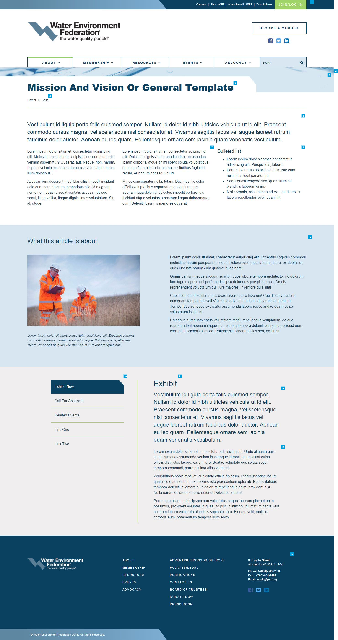

* + 1. Widget Table

|  |  |  |  |
| --- | --- | --- | --- |
| Footnote | Name | Functional Use Case | Implementation Guide |
| 1 | Header and Main Navigation | These elements have the same functionality as indicated in the notes for widgets 1.3.1-8 on the Homepage (Template 1.3). | Please see Implementation Guide for widgets 1.3.1-8 on the Homepage. |
| 2 | General Smart Form | The [general] smart form contains elements used to construct the landing page. | ** The following [field name] (and type) are defined within the general smart form: **  The following fields are contained within the [Main] section: 1) [Page headline] (Text box) 2) [Subheader Teaser] (Text box) 3) [Subhead Body Copy - Left] (Text box) 4) [Subhead Body Copy - Right] (Text box) 5) [Subheader] (Content selector / Subheader smart form) - Please see Implementation Guide for widgets 1.9.2-7 on the Leadership page.   The following fields are contained within the [Accordion flipper] section: 6) [General] (Repeater)  a) [General Menu] - Automatically defined when repeater record entered. Each menu item corresponds to a general headline entry.  b) [General Headline] (Text box)  c) [General Teaser] (Text box)  d) [General Body Copy] (Text box) |
| 3 | Page Headline | Depending on the length of the page title, the white container will expand to the right. | This is to be managed via the general smart form. |
| 4 | Breadcrumb | Breadcrumb | This is implemented as an Ektron out-of-the-box folder control |
| 5 | Background Image | This image does not need to be managed. It stays fixed with a scrolling parallel effect. The positioning is higher or lower based on the template. Please see mark-up. | Not applicable as this is handled as a front-end development effort. |
| 6 | Subhead Teaser | This is considered subhead text and should allow no more than 3 lines of text. The standard text size is 24 pt. If this field is blank, the body text replaces this section.  An administrator should be able to edit this text. | This is to be managed via the general smart form. |
| 7 | Subhead Body Copy - Left | This is considered body copy and should have the capability to use simple WYSIWYG functions on their text.  Styling should be limited to bold, italic, underline, bulleted and numbered lists, etc.  The size of text is determined by type of content.  If using body copy, the text size is 16 pt.  An administrator should be able to edit this text. | This is to be managed via the general smart form. |
| 8 | Subhead Body Copy - Right | This is considered body copy and should have the capability to use simple WYSIWYG functions on their text.  Styling should be limited to bold, italic, underline, bulleted and numbered lists, etc.  The size of text is determined by type of content.  If using body copy, the text size is 16 pt.  An administrator should be able to edit this text. | This is to be managed via the general smart form. |
| 9 | Subheader | This element has the same functionality as indicated in the notes for widgets 1.9.2-7 on the Leadership page (Template 1.9). | This is to be managed via the general smart form.  Please see Implementation Guide for widgets 1.9.2-7 on the Leadership page. |
| 10 | General Menu | As a user selects a different subject, the Subject Title will highlight and the content to the right will animate in with a simple fade-in.  An administrator should be able to add subjects, remove subjects, reorder subjects and edit the text.  @@ What is the recommended max? @@ | This is to be managed via the general smart form.  @@ WEF to discuss accordion interaction with Mintium @@ |
| 11 | General Headline | An administrator should be able to edit this text.  Headline's max is 2 lines. | This is to be managed via the general smart form. |
| 12 | General Teaser | This text is introductory with a max of 60-70 words. If blank, the body text replaces this section.  An administrator should be able to edit this text. | This is to be managed via the general smart form. |
| 13 | General Body Copy | An administrator should be able to edit this text. | This is to be managed via the general smart form. |
| 14 | Footer | This element has the same functionality as indicated in the notes for widgets 1.3.45-51 on the Home Page (Template 1.3). | Please see Implementation Guide for widgets 1.3.45-51 on the Homepage. |

* 1. Mobile Mission & Vision - General
     1. User Interface

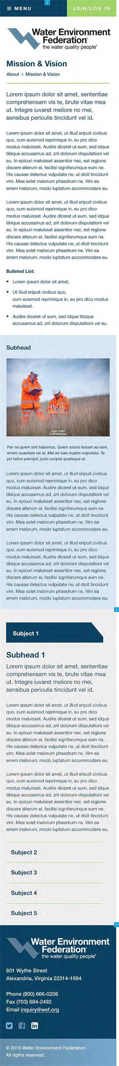

* + 1. Widget Table

|  |  |  |
| --- | --- | --- |
| Footnote | Name | Functional Use Case |
| 1 | Mobile Main Menu Button | This element has the same functionality as indicated in the notes for widgets 1.2.1 on the Mobile Home Page (Template 1.2). |
| 2 | Subject Menu | On mobile, the Subject Menu becomes an accordion. A user should be able to tap the Subject Title and expand its corresponding Subhead Subject Menu body text.   @@ this is not how the markup is working. Please confirm @@  @@ WEF - review leadership responsive page and see how the UX will not work for long (flipper) lists |
| 3 | Mobile Footer | This element has the same functionality as indicated in the notes for widgets 1.2.7 on the Mobile Home Page (Template 1.2). |

* 1. * Leadership
     1. User Interface

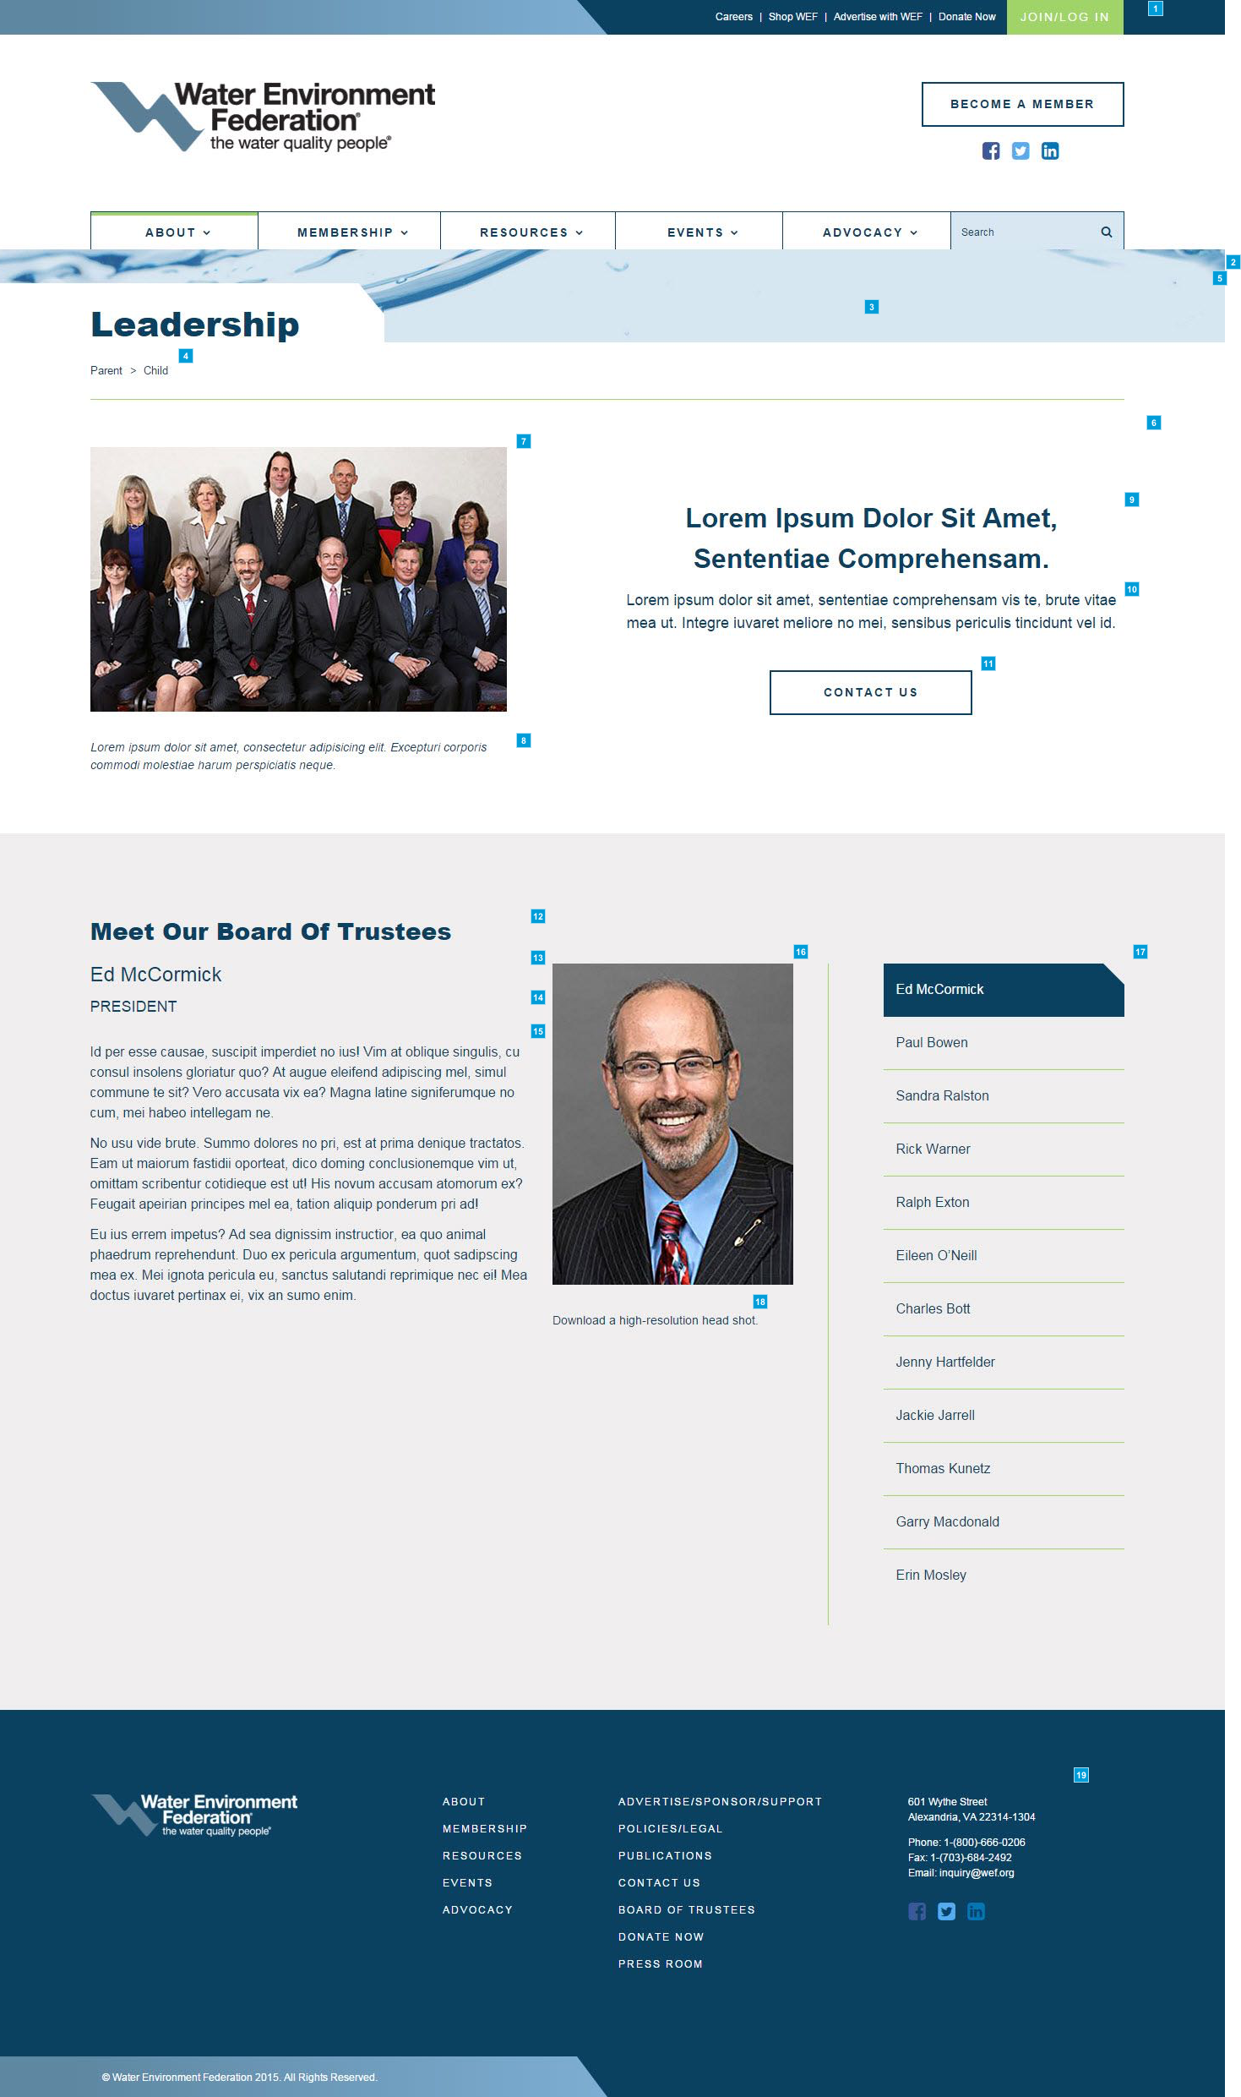

* + 1. Widget Table

|  |  |  |  |
| --- | --- | --- | --- |
| Footnote | Name | Functional Use Case | Implementation Guide |
| 1 | Header and Main Navigation | These elements have the same functionality as indicated in the notes for widgets 1.3.1-8 on the Homepage (Template 1.3). | Please see Implementation Guide for widgets 1.3.1-8 on the Homepage. |
| 2 | Leadership Smart Form | The [leadership] smart form contains elements used to construct the leadership page. | ** The following [field name] (and type) are defined within the leadership smart form: **  The following fields are contained within the [Main] section: 1) [Page headline] (Text box) 2) [Subheader] (Content selector / Subheader smart form)   The following fields are contained within the [Accordion flipper] section: 3) [Leadership] (Repeater)  a) [Leadership Menu] - Automatically defined when repeater record entered. Each menu item corresponds to a leadership headline entry.  b) [Leadership Name] (Text box)  c) [Leadership Title] (Text box)  d) [Leadership Body Copy] (Text box)  e) [Leadership Headshot] (Text box)  f) [Leadership Download Copy Link] (Hyperlink selector) - VINCENT - confirm with TANUJ  g) [Leadership Download Copy Text] (Text box) |
| 3 | Page Headline | Depending on the length of the page title, the white container will expand to the right. | This is to be managed via the leadership smart form. |
| 4 | Breadcrumb | Breadcrumb | This is implemented as an Ektron out-of-the-box folder control |
| 5 | Background Image | This image does not need to be managed. It stays fixed with a scrolling parallel effect. The positioning is higher or lower based on the template. Please see mark-up. | Not applicable as this is handled as a front-end development effort. |
| 6 | Subheader Smart Form | The [subheader] smart form contains elements used to construct the subheader. | ** The following [field name] (and type) are defined within the subheader smart form: **  1) [Subheader Image] (Image Selector) 2) [Subheader Image Caption] (Text box) 3) [Subheader Headline] (Text box) 4) [Subheader Teaser] (Text box) 5) [Subheader CTA Link] (Hyperlink selector) 6) [Subheader CTA Text] (Text box)   NOTE: This subheader smart form may be used within the following PARENT smart form:  1) Leadership page 2) Landing page 3) Mission & Vision (General) page  4) Biosolids (Topic) page |
| 7 | Subheader Image | An administrator should be able to add/edit this image.   An administrator can place video here instead of an image. Video will play in frame. | This is to be managed via the subheading smart form. |
| 8 | Subheader Image Caption | An administrator can add captions to photos. If there is no content, then it does not appear.   Captions should be no longer than two lines in length and the text size is 14 pt. 14 pt is the minimum size for text on this site. | This is to be managed via the subheading smart form. |
| 9 | Subheader Headline | An administrator should be able to edit this text. If there is no content, then it does not appear.   Headline's max is 2 lines. | This is to be managed via the subheading smart form. |
| 10 | Subheader Teaser | An administrator should be able to edit this text.   Leadership page - This body text's max is 3 lines (recommended). Landing page - This body text's max is 4 lines (recommended). Mission & Vision (General) page - This body text does not have a character max count. Biosolids (Topic) page - This body text does not have a character max count. | This is to be managed via the subheading smart form. |
| 11 | Subheader CTA | An administrator should be able to edit the text of this CTA button and its destination link. If there is no content, then it does not appear.   On hover, button background becomes dark blue and text becomes light blue. | This is to be managed via the subheading smart form. |
| 12 | Leadership Headline | An administrator should not be able to edit this text.   Headline's max is 2 lines. | This is automatically defined within the control. |
| 13 | Leadership Name | An administrator should be able to edit this text. | This is to be managed via the leadership smart form. |
| 14 | Leadership Title | An administrator should be able to edit this text. | This is to be managed via the leadership smart form. |
| 15 | Leadership Body Copy | An administrator should be able to edit this text. | This is to be managed via the leadership smart form. |
| 16 | Leadership Headshot | An administrator should be able to edit this image. | This is to be managed via the leadership smart form. |
| 17 | Leadership Menu | As a user selects a different subject, the Subject Title will highlight and the content to the right will animate in with a simple fade-in.  An administrator should be able to add subjects, remove subjects, reorder subjects and edit the text.  @@ What is the recommended max? @@ | This is to be managed via the leadership smart form.  @@ WEF to discuss accordion interaction with Mintium @@ |
| 18 | Leadership Download Copy | An administrator should be able to edit this text.   @@ WEF may update text to say ‘Right click to download…’ This text is on every bio image. Also include download icon from Mintium. @@ | This is to be managed via the leadership smart form. |
| 19 | Footer | This element has the same functionality as indicated in the notes for widgets 1.3.45-51 on the Home Page (Template 1.3). | Please see Implementation Guide for widgets 1.3.45-51 on the Homepage. |

* 1. * Staff Directory
     1. User Interface

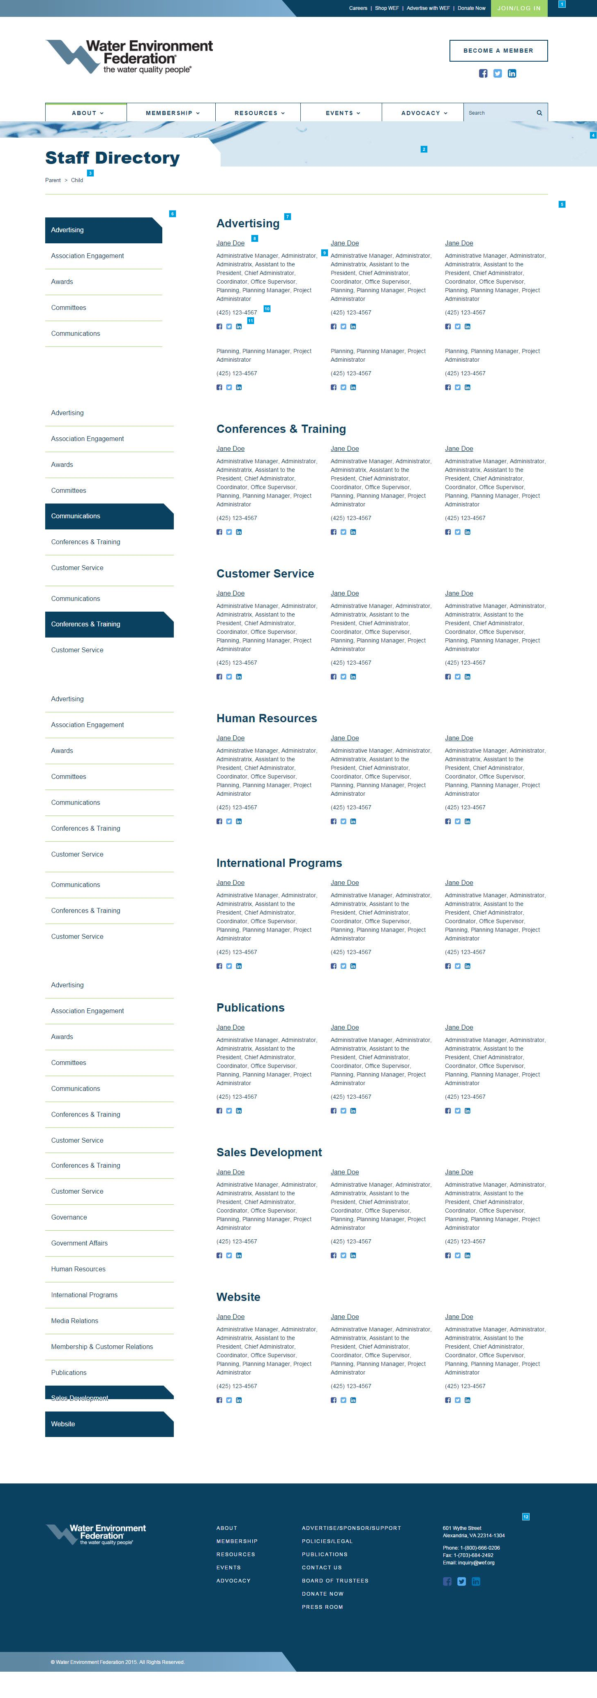

* + 1. Widget Table

|  |  |  |  |
| --- | --- | --- | --- |
| Footnote | Name | Functional Use Case | Implementation Guide |
| 1 | Header and Main Navigation | These elements have the same functionality as indicated in the notes for widgets 1.3.1-8 on the Homepage (Template 1.3). | Please see Implementation Guide for widgets 1.3.1-8 on the Homepage. |
| 2 | Page Headline | Depending on the length of the page title, the white container will expand to the right. | This is to be managed via the staff directory smart form. |
| 3 | Breadcrumb | Breadcrumb | This is implemented as an Ektron out-of-the-box folder control |
| 4 | Background Image | This image does not need to be managed. It stays fixed with a scrolling parallel effect. The positioning is higher or lower based on the template. Please see mark-up. | Not applicable as this is handled as a front-end development effort. |
| 5 | Staff Directory Smart Form | The [staff directory] smart form contains elements used to construct the staff directory.  The maximum number of columns of staff members is 3 (desktop view). An administrator should be able to edit staff members and their contact information. Staff department, name, job title (manual entry) and phone are mandatory. Social links are optional.  VINCENT - Need a new markup from Mintium for email address. | ** The following [field name] (and type) are defined within the staff directory smart form: **  1) [Staff] (Repeater)  a) [Department] (Text box)  b) [Name] (Text box)  c) [Job Title] (Text box)  d) [Phone] (Text box)  e) [Social] (ShareThis add-on)  Note: all fields are mandatory except for the social icons. |
| 6 | Quick Link Menu | When a user clicks on a department, content will jump to that department and list it first. When a user scrolls, the content on the right will move down. The dark blue highlight on the left menu will move to the correct section title when that section on the right reaches the top. The department is sorted in alpha-numeric ascending order.  An administrator should be able to add subjects, remove subjects, reorder subjects and edit the text.  @@ * Need a new screenshot as the left nav is corrupt @@ | This is to be managed via the staff directory smart form.  @@ WEF to discuss accordion interaction with Mintium @@ |
| 7 | Department Headline | @@ WEF - Need to follow up on how this is implemented. e.g. dept is a text field or dropdown? @@ VINCENT - TEXTbox | This is to be managed via the staff directory smart form.  Note: Each unique department headline is only displayed once regardless of the number of staff entered within the repeater. |
| 8 | Staff Name | A user should be able to click the staff member's name and trigger an email through the user's default email client with only the staff member's email address auto-populated in the recipient box.  An administrator should be able to edit this text and the email link.  VINCENT - ?? Is there a Javascript to add to the email, so it wouldn’t be harvested ?? can the email be converted to an image? | This is to be managed via the staff directory smart form. |
| 9 | Staff Job Title | An administrator should be able to edit this text. | This is to be managed via the staff directory smart form. |
| 10 | Staff Job Title | An administrator should be able to edit this text. | This is to be managed via the staff directory smart form. |
| 11 | Share icons | A user should be able to click a share icon and a modal window appears where they can share the information without leaving the current staff directory page. | Share icons to be implemented via the ShareThis add-on. |
| 12 | Footer | This element has the same functionality as indicated in the notes for widgets 1.3.45-51 on the Home Page (Template 1.3). | Please see Implementation Guide for widgets 1.3.45-51 on the Homepage. |

* 1. * Upcoming Events
     1. User Interface

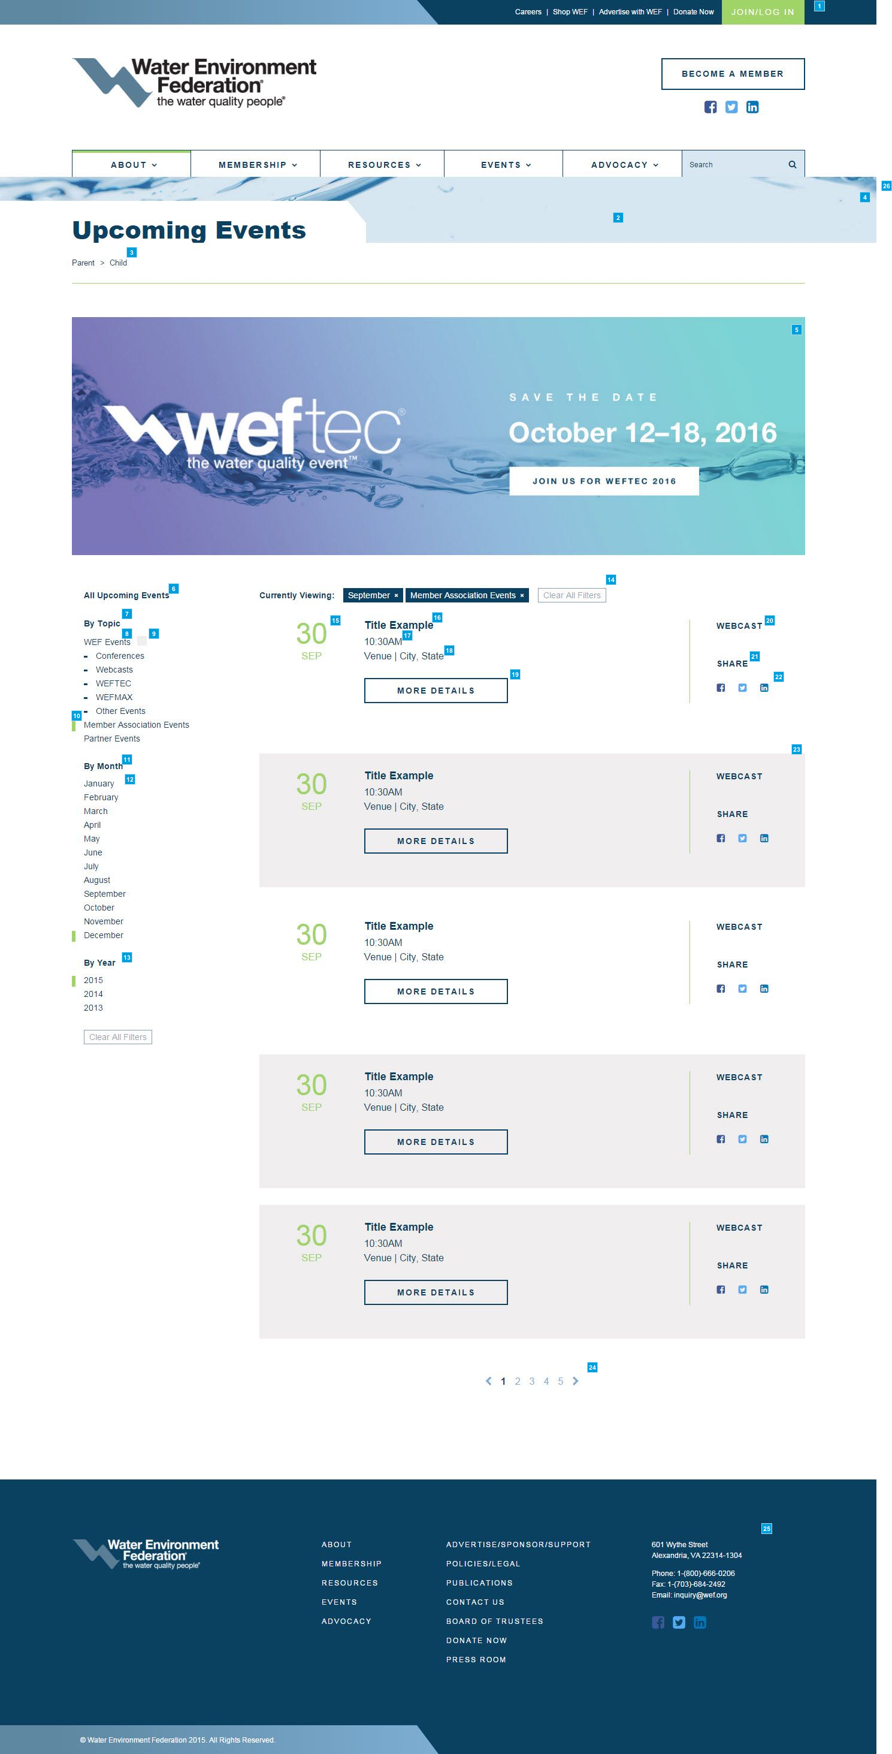

* + 1. Widget Table

|  |  |  |  |
| --- | --- | --- | --- |
| Footnote | Name | Functional Use Case | Implementation Guide |
| 1 | Header and Main Navigation | These elements have the same functionality as indicated in the notes for widgets 1.3.1-8 on the Homepage (Template 1.3). | Please see Implementation Guide for widgets 1.3.1-8 on the Homepage. |
| 2 | Page Headline | Depending on the length of the page title, the white container will expand to the right. | This is to be managed via the upcoming events smart form. |
| 3 | Breadcrumb | Breadcrumb | This is implemented as an Ektron out-of-the-box folder control |
| 4 | Background Image | This image does not need to be managed. It stays fixed with a scrolling parallel effect. The positioning is higher or lower based on the template. Please see mark-up. | Not applicable as this is handled as a front-end development effort. |
| 5 | Upcoming Events Banner CTA | This banner size should be 1280 (full width) x 415 px.  An administrator should be able to manage the banner to promote different events (e.g., dates are not automatically pulled into the banner). This is a single image that redirects to a separate page. Clicking anywhere on the image will redirect the user | This is to be managed via the upcoming events smart form. |
| 6 | All Upcoming Events Headline | An administrator should not be able to edit this text. | This is automatically defined within the control. |
| 7 | By Topic Headline | An administrator should not be able to edit this text. | This is automatically defined within the control. |
| 8 | Event Type Filters | These filters represent different types of events.  A user should be able to select an event type and filter the events on the right to display the selected types of events. | An administrator should be able to manage the event taxonomy.  NOTE: Taxonomy as displayed in markup is the exact taxonomy to implement. |
| 9 | WEF Event Grey Box Filter | This indicates a WEF Event.  A user should be able to click this and filter the events on the right to display the WEF events. | This is automatically defined within the control. |
| 10 | Rectangle Current Area Indicator | This rectangle indicates what **filters are currently being applied**. A user should be able to see this and better orient themselves on the site. | This is automatically defined within the control. |
| 11 | By Month Headline | An administrator should not be able to edit this text. | This is automatically defined within the control. |
| 12 | Event Month and Year Filters | These filters represent all events for the displayed month and year.  A user should be able to select an event month or year and filter the events on the right to display the selected filter. | An administrator should be able to manage the event month and year. |
| 13 | By Year Headline | An administrator should not be able to edit this text. | This is automatically defined within the control. |
| 14 | Currently Viewing | This will show a user what filters are being applied to the list of events below.  Clicking "Clear All Filters" should show all events. | This is automatically defined within the control. |
| 15 | Upcoming Event Date | @@ WEF - is this the start date? what if the conf is a date range? how will it be displayed? Need to look at the 'time' field for multiple date ranges. @@ | This is to be managed via the individual event details smart form.  Please see Implementation Guide for widgets 1.12.5-12 on the Event - Details page. |
| 16 | Upcoming Event Headline | The Event Title can go to multiple lines; if so, the individual section height will increase.  An administrator should be able to edit this text. | This is to be managed via the individual event details smart form.  Please see Implementation Guide for widgets 1.12.5-12 on the Event - Details page. |
| 17 | Upcoming Event Time | An administrator should be able to edit this text. | This is to be managed via the individual event details smart form.  Please see Implementation Guide for widgets 1.12.5-12 on the Event - Details page. |
| 18 | Upcoming Event Location | An administrator should be able to edit this text. | This is to be managed via the individual event details smart form.  Please see Implementation Guide for widgets 1.12.5-12 on the Event - Details page. |
| 19 | Upcoming Event CTA | **On hover, button background becomes dark blue and text becomes light blue.**  An administrator should be able to edit the text of this call to action button and its destination link. | This is to be managed via the upcoming events smart form. |
| 20 | Upcoming Event Topic | An administrator should be able to edit this text. | This is to be managed via the individual event details smart form.  Please see Implementation Guide for widgets 1.12.5-12 on the Event - Details page. |
| 21 | Upcoming Event Share Headline | An administrator should not be able to edit this text. | This is automatically defined within the control. |
| 22 | Social Media Share Icons | These social media links would be unique to the event.  A user should be able to click on a share icon for a social network to**share the event on their social network**  An administrator should be able to manage social media share links.  @@ WEF would like to share content without leaving the page @@ | This is to be managed via the individual event details smart form.  Please see Implementation Guide for widgets 1.12.5-12 on the Event - Details page. |
| 23 | WEF Event Indicator - Grey Box | The gray box indicates that this is a WEF event.   An administrator should be able to toggle between whether an event is a WEF event or an external event. | This is automatically defined within the control.  VINCENT - Date is a text box where WEF controls content . need 2 date fields for start and end b/c it’s going to be sorted in the home page. Need to allow WEF to enter both date and time for start and end date. If a field is blank, do not display. If the end date/time is configured, the display both date/time with the word ‘through’ between the fields. |
| 24 | Pagination Controls | Pagination should allow five (5) events to be displayed per page (default). Admin should be able to edit this field. If there are fewer than 5 events, the pagination controls are hidden. | This is to be managed via the upcoming events smart form. |
| 25 | Footer | This element has the same functionality as indicated in the notes for widgets 1.3.45-51 on the Home Page (Template 1.3). | Please see Implementation Guide for widgets 1.3.45-51 on the Homepage. |
| 26 | Upcoming Events Smart Form | The [staff directory] smart form contains elements used to construct the staff directory.  The maximum number of columns of staff members is 3 (desktop view). An administrator should be able to edit staff members and their contact information. Staff department, name, job title (manual entry) and phone are mandatory. Social links are optional.  VINCENT - Need a new markup from Mintium for email address. | ** The following [field name] (and type) are defined within the upcoming events smart form: **  The following fields are contained within the [Main] section: 1) [Page headline] (Text box) 2) [Upcoming Events Banner CTA Link] (Hyperlink selector) 3) [Upcoming Events Banner CTA Image] (Image selector) 4) [Individual CTA Link] (Hyperlink selector) 5) [Individual CTA Text] (Text box) 6) [Pagination - Events per page] (Text box) - Default to 5  Note: Individual events are pulled in from a specified [Event Details] folder. Only events marked as 'Active' are displayed and filtered. |

* 1. * Event - Details
     1. User Interface

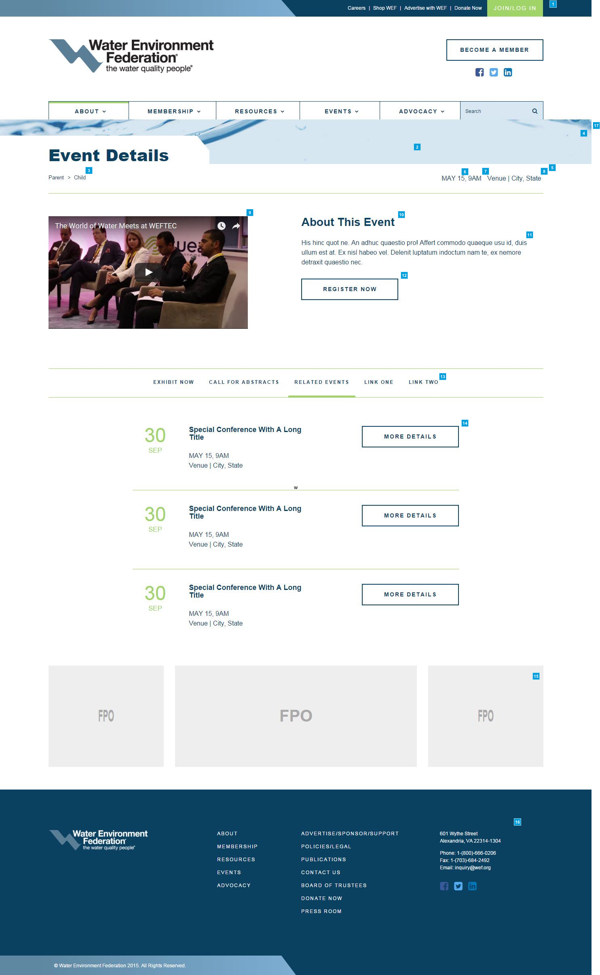

* + 1. Widget Table

|  |  |  |  |
| --- | --- | --- | --- |
| Footnote | Name | Functional Use Case | Implementation Guide |
| 1 | Header and Main Navigation | These elements have the same functionality as indicated in the notes for widgets 1.3.1-8 on the Homepage (Template 1.3). | Please see Implementation Guide for widgets 1.3.1-8 on the Homepage. |
| 2 | Page Headline | Depending on the length of the page title, the white container will expand to the right. | This is to be managed via the event details smart form. |
| 3 | Breadcrumb | Breadcrumb | This is implemented as an Ektron out-of-the-box folder control |
| 4 | Background Image | This image does not need to be managed. It stays fixed with a scrolling parallel effect. The positioning is higher or lower based on the template. Please see mark-up. | Not applicable as this is handled as a front-end development effort. |
| 5 | Individual Event Details Smart Form | The [individual event detail] smart form contains elements used to construct the individual event detail. | ** The following [field name] (and type) are defined within the individual event detail smart form: **  The following fields are contained within the [Main] section: 1) [Active] (Check box) - If checked, this event is displayed online. Defaults to checked. 2) [Event Date] (Text box) 3) [Event Time] (Text box) 4) [Event Venue] (Text box) 5) [Event City and State] (Text box) 6) [Event Image] (Image selector) 7) [Event Headline] (Text box) 8) [Event Teaser] (Text box) 9) [Event CTA Link] (Hyperlink selector) 10) [Event CTA Text] (Text box) 11) [Event Social] (ShareThis add-on)  Note: Individual events are pulled in from a specified [Event Details] folder. Only events marked as 'Active' are displayed.   The following fields are contained within the [Event Slider] section: 12) [Event Slider] (Repeater) - Note that there is a max of six (6) slider headers. Related events is displayed as the last slider. VINCENT - confirm with WEF.  Note: the following fields are contained within the non-related events slider (not pictured here, please see markup for visual details):  a) [Slider Headline] (Text box)  b) [Slider Teaser] (Text box)  Note: the following fields are contained within the related events slider:  a) [Event Headline] (Text box)  b) [Event Content Id 1] (Text box)  c) [Event Content Id 2] (Text box)  d) [Event Content Id 3] (Text box)  e) Related Event Date - Automatically defined when event content id selected.  f) Related Event Headline - Automatically defined when event content id selected.  g) Related Event Date and Time - Automatically defined when event content id selected.  h) Related Event Venue, City and State - Automatically defined when event content id selected.  i) Related Event CTA Link - Automatically defined when event content id selected.  k) Related Event CTA Text - An administrator should be not able to edit this text.  Note: Individual RELATED events are pulled in from a specified [Event Details] folder. Only RELATED events marked as 'Active' are displayed. |
| 6 | Event Date | Format: Month, Day, Year  An administrator should be able to edit this text.  @@ Year?? What about date range?? @@ | This is to be managed via the individual event details smart form. |
| 7 | Event Time | Format: 00:00 AM EST  An administrator should be able to edit this text.  @@ show timze zone also? @@ VINCENT - no timezone | This is to be managed via the individual event details smart form. |
| 8 | Event Venue | City, State | If any of this content is not provided, it should be hidden.  An administrator should be able to edit this text.  @@ what does wrapping look like if everything can't be displayed on the same line? the breadcrumb might be long and the venue/location might overlap @@ VINCENT - 3 char month. 2 char state. Remove venue (WEF to get back on this) | This is to be managed via the individual event details smart form. |
| 9 | Event Image | An administrator should be able to add/edit this image.   An administrator can place video here instead of an image. Video will play in frame. | This is to be managed via the individual event details smart form. |
| 10 | Event Headline | An administrator should be able to edit this text. | This is to be managed via the individual event details smart form.  VINCENT - WEF wanted this field updated from a hardcoded text to the event header. |
| 11 | Event Teaser | This is the max amount of copy and is intended as an introduction.   An administrator can add a navigation item to the content slider (ex. Event Details) for specific event details, and can use the length of the page to go into detail about a special speaker or feature for promotion.  An administrator should be able to edit this text. | This is to be managed via the individual event details smart form. |
| 12 | Event CTA | On hover, button background becomes dark blue and text becomes light blue.  An administrator should be able to edit the text of this call to action button and its destination link. | This is to be managed via the individual event details smart form. |
| 13 | Content Slider | This will work as a content slider. A user should be able to click on a topic and the content below will fade into place. The maximum number of topics is 6.  An administrator should be able to edit this text. | This is to be managed via the event details smart form. |
| 14 | Related Events | Only the top 3 upcoming related events will appear in the Related Events Topic section of the content slider. | This is to be managed via the individual event details smart form.  Note: Individual RELATED events are pulled in from a specified [Event Details] folder. Only RELATED events marked as 'Active' are displayed. |
| 15 | Ad Deck | @@ WEF to implement using Ban Man Pro @@ | Ban Man Pro script will be the data source which will populate the Ad Sublayout.  The Ad Sublayout is a component of the Homepage Page Layout. |
| 16 | Footer | This element has the same functionality as indicated in the notes for widgets 1.3.45-51 on the Home Page (Template 1.3). | Please see Implementation Guide for widgets 1.3.45-51 on the Homepage. |
| 17 | Event Details Smart Form | The [event details] smart form contains elements used to construct the event details page. | ** The following [field name] (and type) are defined within the event details smart form: **  The following fields are contained within the [Main] section: 1) [Page headline] (Text box) 2) [Event Details] - This is automatically displayed base on the event detail content id being passed in (when use clicks more details from the upcoming events page). Also, this page may be linked from any content page that references this specific event detail content id (within the correct URL). 3) [Ad Card] (Text box) - VINCENT - need to ask Tanuj how this will be managed?  Note: Individual events are pulled in from a specified [Event Details] folder. Only events marked as 'Active' are displayed. |

* 1. * Log In
     1. User Interface

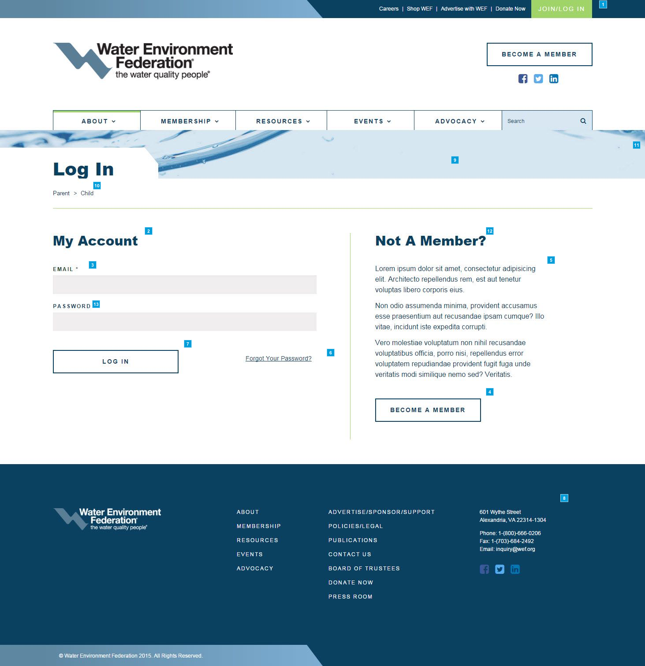

* + 1. Widget Table

|  |  |  |  |
| --- | --- | --- | --- |
| Footnote | Name | Functional Use Case | Implementation Guide |
| 1 | Header and Main Navigation | These elements have the same functionality as indicated in the notes for widgets 1.3.1-8 on the Homepage (Template 1.3). | Please see Implementation Guide for widgets 1.3.1-8 on the Homepage. |
| 2 | "My Account" Header | An administrator should not be able to edit this text. | This is the standard Personify SSO Login aspx page. |
| 3 | Email Address Text Field | Field should produce an error after clicking login button if proper email format is not met.  If a user does not use the "@" symbol or does not enter the proper email format, this text field should produce an error when the user clicks the "Log In" button or hits "Enter" on their keyboard.   Error handling and formatting will be provided in the WEF design comp. | This is the standard Personify SSO Login aspx page. |
| 4 | Become a Member CTA | An administrator should be able to edit this text or hyperlink. | This is the standard Personify SSO Login aspx page. |
| 5 | Not a Member Body Copy | An administrator should not be able to edit this text. | This is the standard Personify SSO Login aspx page. |
| 6 | "Forgot Your Password?" text | An administrator should not be able to edit this text.  @@ redirects to seperate page? @@ | This is the standard Personify SSO Login aspx page. |
| 7 | "Log In" Text | @@ editorially managed ??? @@ | This is the standard Personify SSO Login aspx page. |
| 8 | Footer | This element has the same functionality as indicated in the notes for widgets 1.3.45-51 on the Home Page (Template 1.3). | Please see Implementation Guide for widgets 1.3.45-51 on the Homepage. |
| 9 | Page Headline | Depending on the length of the page title, the white container will expand to the right. | This is to be managed via the login smart form.   VINCENT - WEF may have to reconsider having the header and page header section for the Personify SSO page. |
| 10 | Breadcrumb | Breadcrumb  VINCENT - hide? | This is implemented as an Ektron out-of-the-box folder control |
| 11 | Background Image | This image does not need to be managed. It stays fixed with a scrolling parallel effect. The positioning is higher or lower based on the template. Please see mark-up. | Not applicable as this is handled as a front-end development effort. |
| 12 | Not a Member Headline | An administrator should not be able to edit this text. | This is the standard Personify SSO Login aspx page. |
| 13 | Password Text Field | VINCENT - What is WEF's password constraint? | This is the standard Personify SSO Login aspx page. |

* 1. Search Results
     1. User Interface

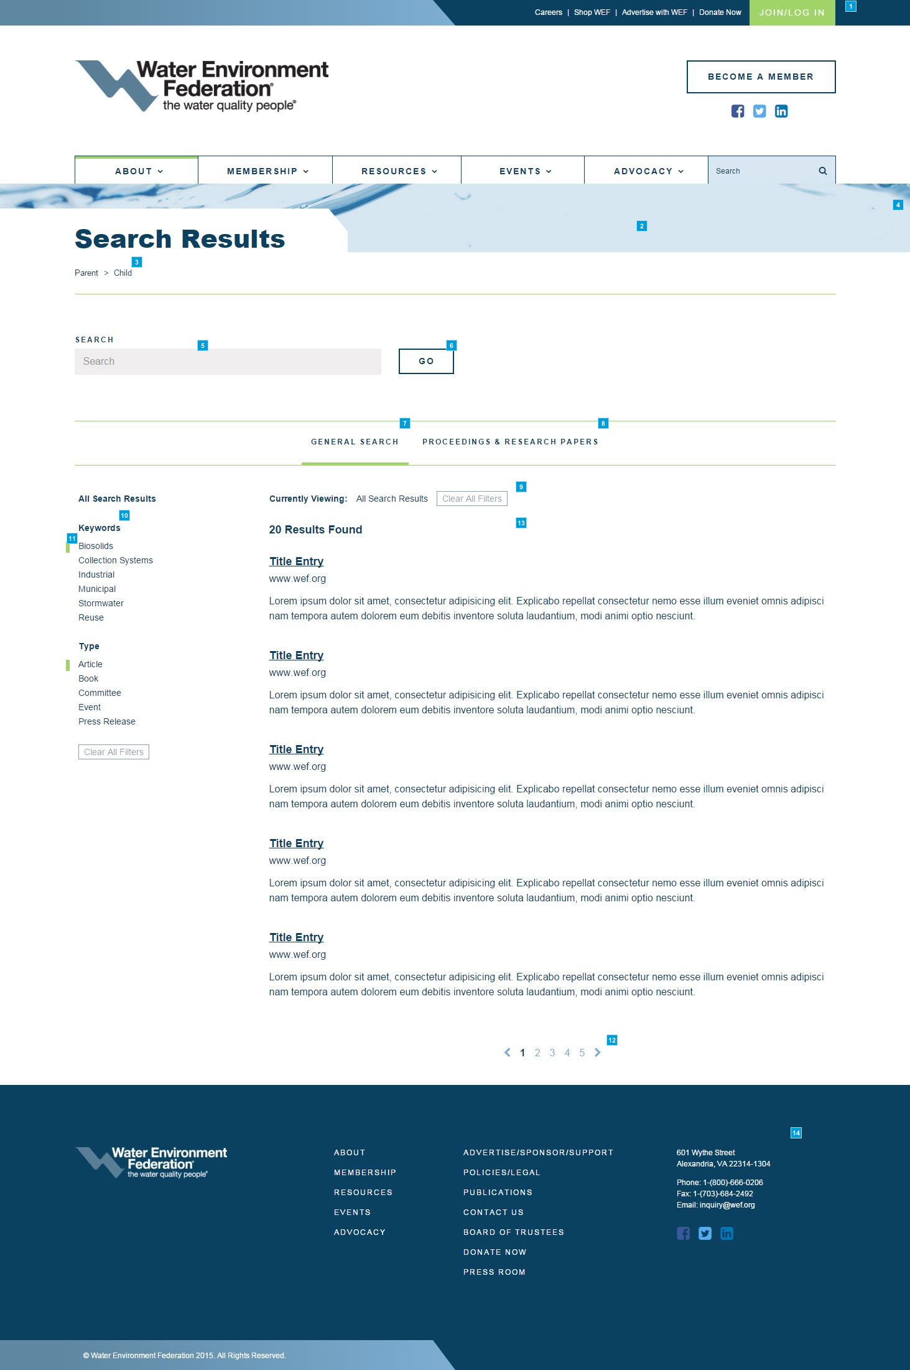

* + 1. Widget Table

|  |  |  |  |
| --- | --- | --- | --- |
| Footnote | Name | Functional Use Case | Implementation Guide |
| 1 | Header and Main Navigation | These elements have the same functionality as indicated in the notes for widgets 1.3.1-8 on the Homepage (Template 1.3). | Please see Implementation Guide for widgets 1.3.1-8 on the Homepage. |
| 2 | Page Headline | Depending on the length of the page title, the white container will expand to the right. | This is to be managed via the Search Results smart form. |
| 3 | Breadcrumb | NO Breadcrumb  VINCENT - WEF doesn not want breadcrums on this page. | This is implemented as an Ektron out-of-the-box folder control |
| 4 | Background Image | This image does not need to be managed. It stays fixed with a scrolling parallel effect. The positioning is higher or lower based on the template. Please see mark-up. | Not applicable as this is handled as a front-end development effort. |
| 5 | Search box | A user can enter search text and then press "enter" or click on "Go" CTA button to initiate the search | This is to be implemented via standard SOLR Search. |
| 6 | "Go" CTA button | On hover, background color becomes grey. | This is to be implemented via standard SOLR Search. |
| 7 | General Search | Default: If a user does a search, the "General Search" will be selected. The results below will display WEF, WEF Tech, eWeb (Personify meeting products), News.WEF.Org, Stormwater.WEF.Org content. | This is to be implemented via standard SOLR Search. |
| 8 | Proceedings & Research Papers (Ingenta) | If a user selects "Proceedings and Research Papers," this will only search content on a third-party site (Ingenta). The results displayed below will be content from third-party sites. | @@ TBD - We are still looking into importing 3rd party site or db into site @@ @@ WEF has scripts to pull in search results. We need to analyze and confirm that it can be used within SOLR @@ |
| 9 | Currently Viewing | A user should see a list of filters that are being applied to the search results below. Clicking Clear All Filters should show all search results. | This is to be implemented via standard SOLR Search. |
| 10 | Keyword/Type Filters | An administrator should be able to manage the keywords and types for the search results filters. | This is to be implemented via standard SOLR Search.  VINCENT - WEF to update cat/sub-cat in Personify to match Ektron’s taxonomy structure so products and content taxonomy remains in sync.   - Publications (Personify) map to Book (Ektron) for the Type cat in search results. So, show ‘Publications’ in the search results  - Automatically map all ‘MTG’ from Personify over to ‘Event’ in search. Events will be pulled from Ektron content and not Personify   @@ WEF (Action item) - Need a new markup for display of category/sub-category. For types, pull in the same info from Personify @@ |
| 11 | Rectangle Current Area Indicator | This rectangle indicates what **filters are currently being applied**. A user should be able to see this and better orient themselves on the site. | @@ Need to follow up with back end dev on how this is implemented. @@ |
| 12 | Pagination Controls | Pagination will display if search returns more than 10 items. | This is to be implemented via standard SOLR Search. |
| 13 | Search Results | @@ Need to follow up with back end dev on how this is implemented. @@ | This is to be implemented via standard SOLR Search. |
| 14 | Footer | This element has the same functionality as indicated in the notes for widgets 1.3.45-51 on the Home Page (Template 1.3). | Please see Implementation Guide for widgets 1.3.45-51 on the Homepage. |

* 1. * FAQ
     1. User Interface

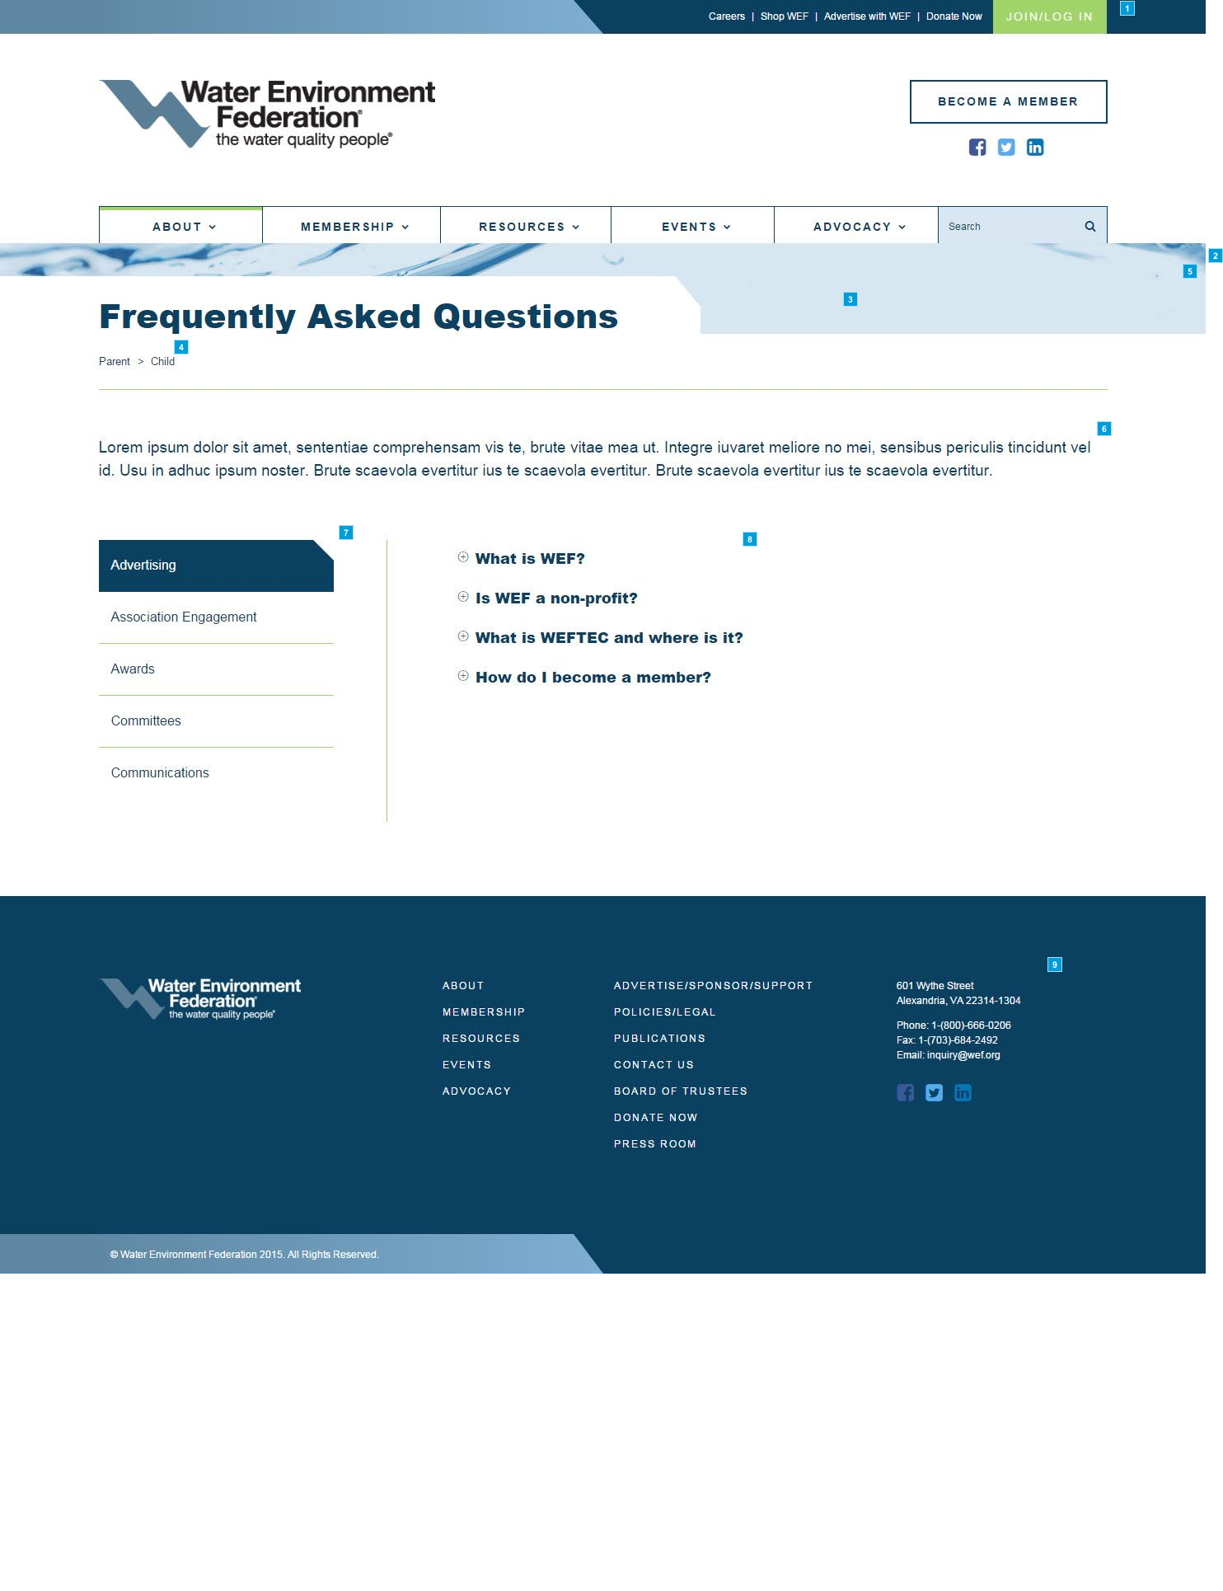

* + 1. Widget Table

|  |  |  |  |
| --- | --- | --- | --- |
| Footnote | Name | Functional Use Case | Implementation Guide |
| 1 | Header and Main Navigation | These elements have the same functionality as indicated in the notes for widgets 1.3.1-8 on the Homepage (Template 1.3). | Please see Implementation Guide for widgets 1.3.1-8 on the Homepage. |
| 2 | FAQ Smart Form | The [FAQ] smart form contains elements used to construct the FAQ page. | ** The following [field name] (and type) are defined within the FAQ smart form: **  The following fields are contained within the [Main] section: 1) [Page headline] (Text box) 2) [FAQ Teaser] (Text box)  The following fields are contained within the [Accordion flipper] section: 3) [FAQ] (Repeater)  a) [FAQ Menu] - Automatically defined when repeater record entered. Each menu item corresponds to a FAQ topic entry.  b) [FAQ Topic] (Text box) - This field is only displayed in the FAQ Menu.  c) [FAQ Question] (Text box)  d) [FAQ Copy Text] (Text box)  Note: FAQ topics are sorted in alpha-numeric order. FAQ topics are sorted based on the sequence as defined in the repeater. |
| 3 | Page Headline | Depending on the length of the page title, the white container will expand to the right. | This is to be managed via the FAQ smart form. |
| 4 | Breadcrumb | Breadcrumb | This is implemented as an Ektron out-of-the-box folder control |
| 5 | Background Image | This image does not need to be managed. It stays fixed with a scrolling parallel effect. The positioning is higher or lower based on the template. Please see mark-up. | Not applicable as this is handled as a front-end development effort. |
| 6 | FAQ Teaser | An administrator should be able to edit this text. | This is to be managed via the FAQ smart form. |
| 7 | FAQ Menu | As a user selects a different subject, the Subject Title will highlight and the content to the right will animate in with a simple fade-in.  An administrator should be able to add subjects, remove subjects, reorder subjects and edit the text.  @@ What is the recommended max? @@ | This is to be managed via the FAQ smart form.  @@ WEF to discuss accordion interaction with Mintium @@ |
| 8 | FAQ Accordion | The FAQs function like an accordion. A user should be able to click the plus (+) or minus (-) symbol and cause it to either expand or collapse the corresponding FAQ content detail and change the plus sign to a minus or vice versa.  If an item's state is expanded, clicking its minus sign will collapse to hide the details and it will change into a plus sign.  If an item's state is collapsed, clicking its plus sign will expand to reveal the details and it will change into a minus sign.  NOTE: The plus sign here indicates that clicking will expand the corresponding detail. Plus signs are used as calls to action and/or links in various other places throughout the site, even if they do not necessarily expand an item upon clicking. We recommend using the plus sign for content that expands on click only and using an alternative symbol for other calls to action. | This is to be managed via the FAQ smart form.  @@ WEF to discuss accordion interaction with Mintium @@ |
| 9 | Footer | This element has the same functionality as indicated in the notes for widgets 1.3.45-51 on the Home Page (Template 1.3). | Please see Implementation Guide for widgets 1.3.45-51 on the Homepage. |

* 1. * Contact Us
     1. User Interface

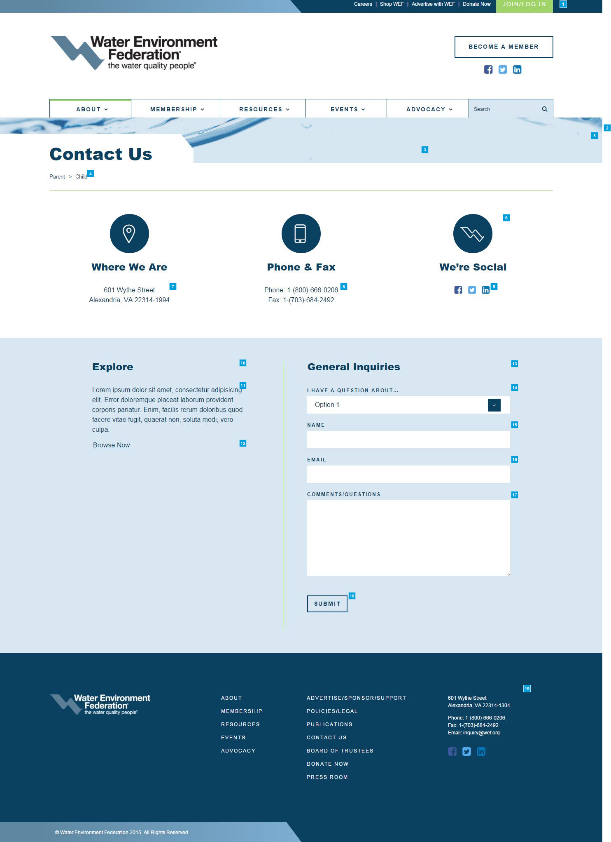

* + 1. Widget Table

|  |  |  |  |
| --- | --- | --- | --- |
| Footnote | Name | Functional Use Case | Implementation Guide |
| 1 | Header and Main Navigation | These elements have the same functionality as indicated in the notes for widgets 1.3.1-8 on the Homepage (Template 1.3). | Please see Implementation Guide for widgets 1.3.1-8 on the Homepage. |
| 2 | Contact Us Smart Form | The [contact us] smart form contains elements used to construct the contact us page.  When the form is submitted, the content is emailed to a managed (multiple) email address, the content is logged within Ektron and a confirmation page is displayed.  An administrator should be able to edit this confirmation text. | ** The following [field name] (and type) are defined within the contact us smart form: **  The following fields are contained within the [Main] section: 1) [Page headline] (Text box) 2) [Contact Us - Address] (Text box) 3) [Contact Us - Phone and Fax] (Text box) 4) [Contact Us - Social] (Repeater) - @@ NEED TO ASK WEF IF THERE IS A LIMIT @@  a) [Icon] (Icon selector)  b) [URL] (Hyperlink selector)  The following fields are contained within the [Contact form] section: 5) [Explore Headline] (Text box) 6) [Explore Teaser] (Text box) 7) [Explore CTA Link] (Hyperlink selector) 8) [Explore CTA Text] (Text box) 9) [General Inquiries Headline] (Text box) 10) [General Inquiries Question Dropdown] (Dropdown) - Administration may configure dropdown text and sort order 11) General Inquiries Name - This is automatically defined within the control. 12) General Inquiries Email - This is automatically defined within the control. 13) General Inquiries Comments/Questions - This is automatically defined within the control. 14) Captcha plugin - This is automatically defined within the control. 15) [General Inquiries CTA Link] (Hyperlink selector) 16) [General Inquiries CTA Text] (Text box) |
| 3 | Page Headline | Depending on the length of the page title, the white container will expand to the right. | This is to be managed via the contact us smart form. |
| 4 | Breadcrumb | Breadcrumb | This is implemented as an Ektron out-of-the-box folder control |
| 5 | Background Image | This image does not need to be managed. It stays fixed with a scrolling parallel effect. The positioning is higher or lower based on the template. Please see mark-up. | Not applicable as this is handled as a front-end development effort. |
| 6 | Contact Us Icons and Headlines | An administrator cannot manage these icons and headlines. | This is automatically defined within the control. |
| 7 | Contact Us - Address | An administrator should be able to manage this content. This is static text with no hyperlink interactions. | This is to be managed via the contact us smart form. |
| 8 | Contact Us - Phone and Fax | An administrator should be able to manage this content. This is static text with no hyperlink interactions. | This is to be managed via the contact us smart form. |
| 9 | Contact Us - Social | A user should be able to click any of these social media icons and be taken to the corresponding social media landing page for WEF.  An administrator can manage, add, and remove icons as necessary, as well as their destination links. | This is to be managed via the contact us smart form. |
| 10 | Explore Headline | An administrator should be able to manage this content. | This is to be managed via the contact us smart form. |
| 11 | Explore Teaser | An administrator should be able to manage this content. | This is to be managed via the contact us smart form. |
| 12 | Explore CTA | An administrator should be able to manage this content and destination link. | This is to be managed via the contact us smart form. |
| 13 | General Inquiries Headline | An administrator should be able to manage this content. | This is to be managed via the contact us smart form. |
| 14 | General Inquiries Question Dropdown | An administrator should be able to manage the items in this dropdown list (including sort). | This is to be managed via the contact us smart form. |
| 15 | General Inquiries Name | There is a 100-character limit. | This is automatically defined within the control. |
| 16 | General Inquiries Email | If a user does not use the "@" symbol or does not enter the proper email format, this text field should produce an error when the user clicks the "Submit" button or hits "Enter" on their keyboard.   This field is mandatory. | This is automatically defined within the control. |
| 17 | General Inquiries Comments/Question | There is a 1000-character limit. If left blank, this text field should produce an error when the user clicks the "Submit" button or hits "Enter" on their keyboard.  This field is mandatory. | This is automatically defined within the control. |
| 18 | General Inquiries CTA | On hover, outline disappears. Background becomes darker blue. This form is submitted when the user clicks the "Submit" button or hits "Enter" on their keyboard.   Captcha plugin is enabled for this page.  When the form is submitted, the content is emailed to a managed (multiple) email address, the content is logged within Ektron and a confirmation page is displayed.  An administrator should be able to edit this confirmation text. | This is to be managed via the contact us smart form.  VINCENT - include captcha. Need new markup???? |
| 19 | Footer | This element has the same functionality as indicated in the notes for widgets 1.3.45-51 on the Home Page (Template 1.3). | Please see Implementation Guide for widgets 1.3.45-51 on the Homepage. |

* 1. * 404 Page Not Found - General HTML
     1. User Interface

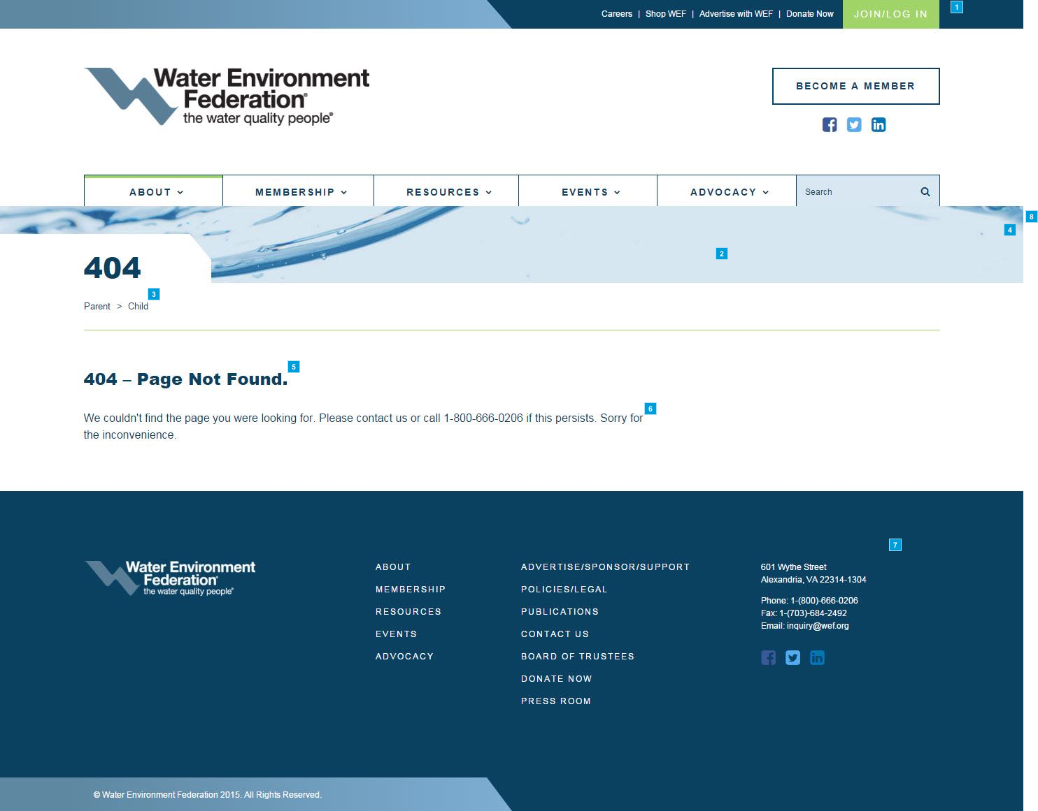

* + 1. Widget Table

|  |  |  |  |
| --- | --- | --- | --- |
| Footnote | Name | Functional Use Case | Implementation Guide |
| 1 | Header and Main Navigation | These elements have the same functionality as indicated in the notes for widgets 1.3.1-8 on the Homepage (Template 1.3). | Please see Implementation Guide for widgets 1.3.1-8 on the Homepage. |
| 2 | Page Headline | Depending on the length of the page title, the white container will expand to the right. | This is to be managed via the general HTML smart form. |
| 3 | Breadcrumb | Breadcrumb | This is implemented as an Ektron out-of-the-box folder control |
| 4 | Background Image | This image does not need to be managed. It stays fixed with a scrolling parallel effect. The positioning is higher or lower based on the template. Please see mark-up. | Not applicable as this is handled as a front-end development effort. |
| 5 | General HTML Headline | An administrator should be able to edit this text. | This is to be managed via the general HTML smart form. |
| 6 | General HTML Teaser | An administrator should be able to edit this text. | This is to be managed via the general HTML smart form. |
| 7 | Footer | This element has the same functionality as indicated in the notes for widgets 1.3.45-51 on the Home Page (Template 1.3). | Please see Implementation Guide for widgets 1.3.45-51 on the Homepage. |
| 8 | General HTML Smart Form | The [general HTML] smart form contains elements used to construct the general HTML page. | ** The following [field name] (and type) are defined within the general HTML smart form: **  The following fields are contained within the [Main] section: 1) [Page headline] (Text box) 2) [General HTML Headline] (Text box) 3) [General HTML Teaser] (Text box) |

* 1. Magazines
     1. User Interface

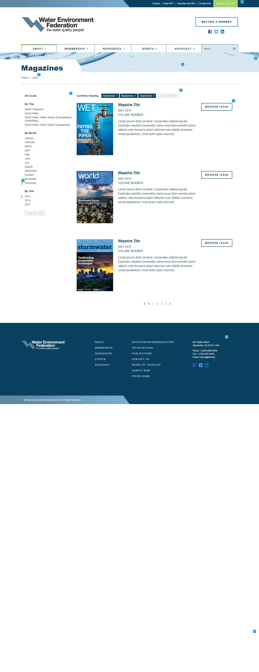

* + 1. Widget Table

|  |  |  |  |
| --- | --- | --- | --- |
| Footnote | Name | Functional Use Case | Implementation Guide |
| 1 | Header and Main Navigation | These elements have the same functionality as indicated in the notes for widgets 1.3.1-8 on the Homepage (Template 1.3). | Please see Implementation Guide for widgets 1.3.1-8 on the Homepage. |
| 2 | Page Headline | Depending on the length of the page title, the white container will expand to the right. | This is to be managed via the magazines smart form. |
| 3 | Breadcrumb | Breadcrumb | This is implemented as an Ektron out-of-the-box folder control |
| 4 | Background Image | This image does not need to be managed. It stays fixed with a scrolling parallel effect. The positioning is higher or lower based on the template. Please see mark-up. | Not applicable as this is handled as a front-end development effort. |
| 5 | Currently Viewing | This will show a user what filters are being applied to the list of events below.  Clicking "Clear All Filters" should show all events. |  |
| 6 | Issue Filters | These filters represent different editions of the magazines.  A user should be able to select by magazine title, month, or year. -   An administrator should be able to manage these filters. | VINCENT - Date is a text field for display. Then a separate date field used for sorting.  Taxonomy is defined in markup.  Sort by publication date (manually maintained)  WEF to find out if there are quarterly subscriptions. And how to display if true. |
| 7 | Browse Issue CTA button | On hover, button background becomes dark blue and text becomes light blue. | VINCENT - Redirect users to another detail page (mission & vision – General).   This page is a preview page and links within this page will redirect to another authorized (role) page. This tierchery page will also be a general template page. |
| 8 | Rectangle Current Area Indicator | This rectangle indicates what **filters are currently being applied**. A user should be able to see this and better orient themselves on the site. |  |
| 9 | Footer | This element has the same functionality as indicated in the notes for widgets 1.1.40-45 on the Home Page (Template 1.1). |  |
| 10 | Footer | This element has the same functionality as indicated in the notes for widgets 1.3.45-51 on the Home Page (Template 1.3). | Please see Implementation Guide for widgets 1.3.45-51 on the Homepage. |

* 1. Press Releases
     1. User Interface

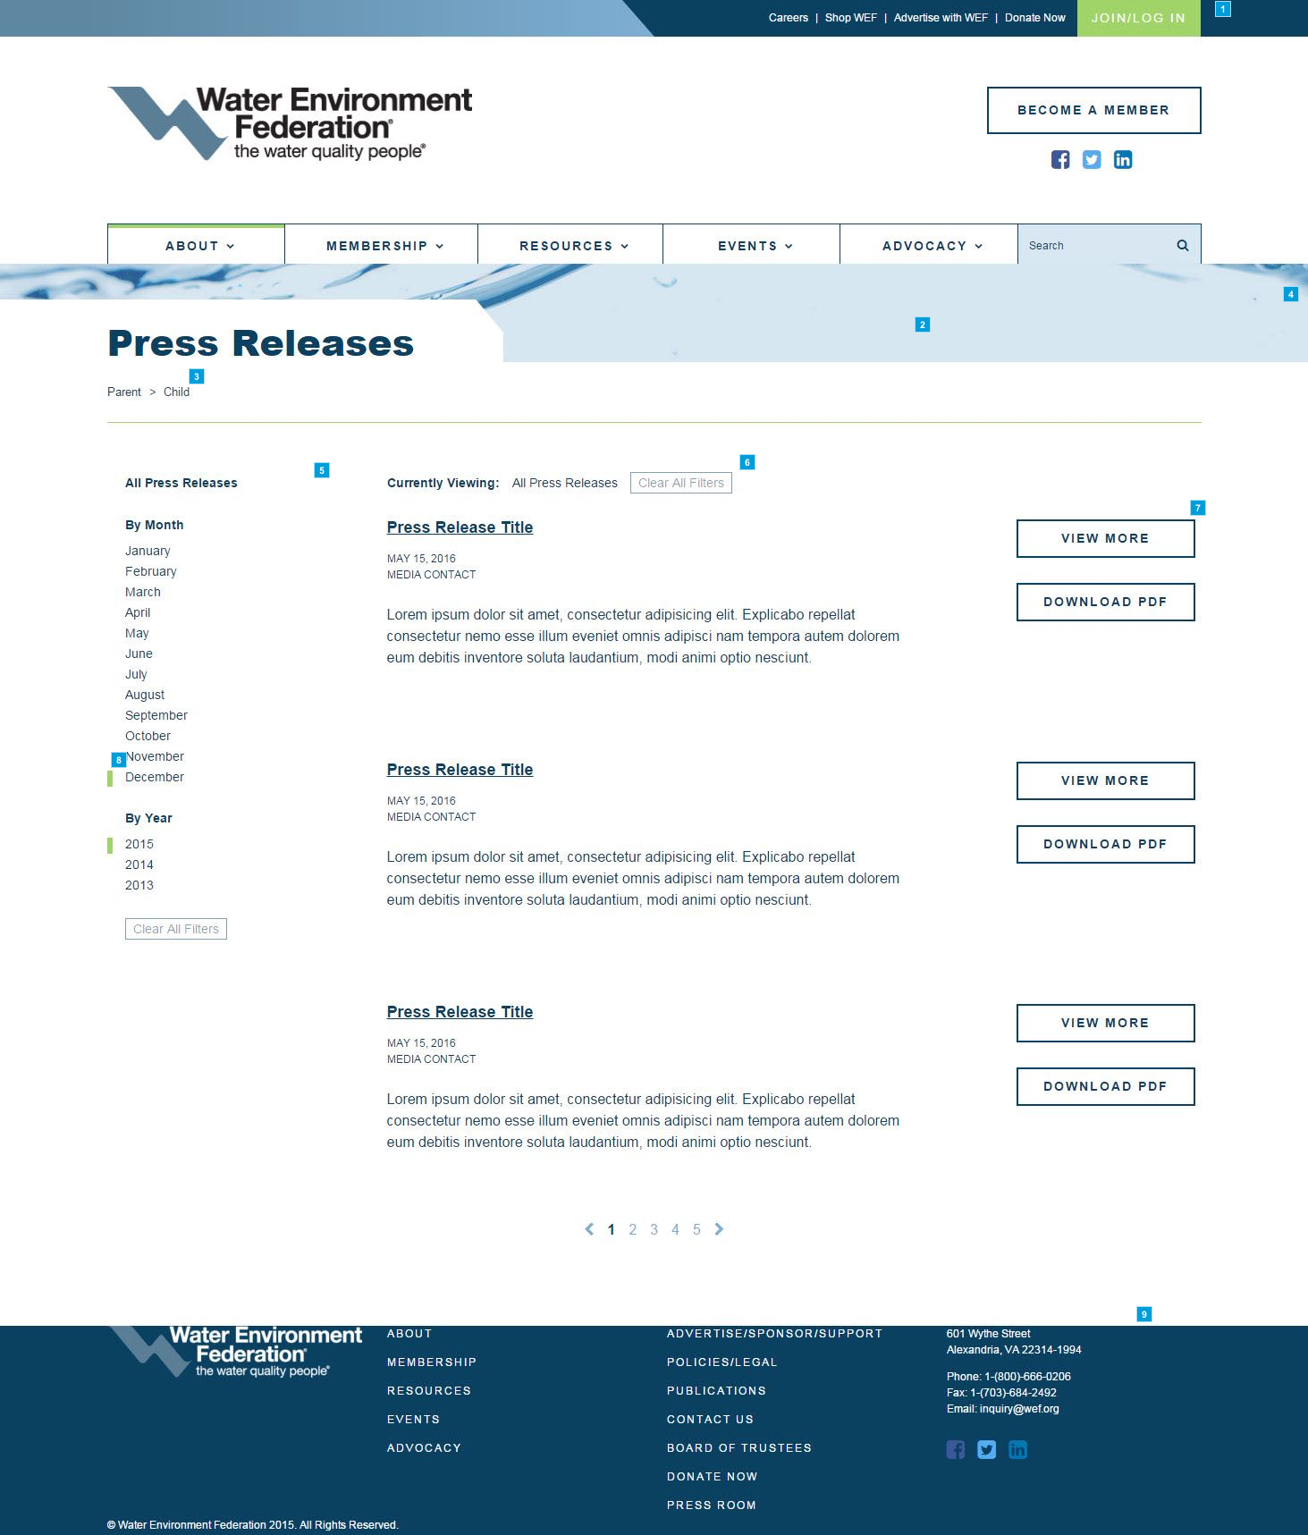

* + 1. Widget Table

|  |  |  |  |
| --- | --- | --- | --- |
| Footnote | Name | Functional Use Case | Implementation Guide |
| 1 | Header and Main Navigation | These elements have the same functionality as indicated in the notes for widgets 1.3.1-8 on the Homepage (Template 1.3). | Please see Implementation Guide for widgets 1.3.1-8 on the Homepage. |
| 2 | Page Headline | Depending on the length of the page title, the white container will expand to the right. | This is to be managed via the press release smart form. |
| 3 | Breadcrumb | Breadcrumb | This is implemented as an Ektron out-of-the-box folder control |
| 4 | Background Image | This image does not need to be managed. It stays fixed with a scrolling parallel effect. The positioning is higher or lower based on the template. Please see mark-up. | Not applicable as this is handled as a front-end development effort. |
| 5 | Issue Filters | These filters represent different press releases.  A user should be able to select by month and year.   An administrator should be able to manage these filters. |  |
| 6 | Currently Viewing | This will show a user what filters are being applied to the list of Press Releases below.  Clicking "Clear All Filters" should show all events. |  |
| 7 | View More/ Download CTA button | On hover, button background becomes dark blue and text becomes light blue.  Will pdf display in page, on a new window/tab, or just download? |  |
| 8 | Rectangle Current Area Indicator | This rectangle indicates what **filters are currently being applied**. A user should be able to see this and better orient themselves on the site. |  |
| 9 | Footer | This element has the same functionality as indicated in the notes for widgets 1.3.45-51 on the Home Page (Template 1.3). | Please see Implementation Guide for widgets 1.3.45-51 on the Homepage. |

* 1. * Biosolids - Topics
     1. User Interface

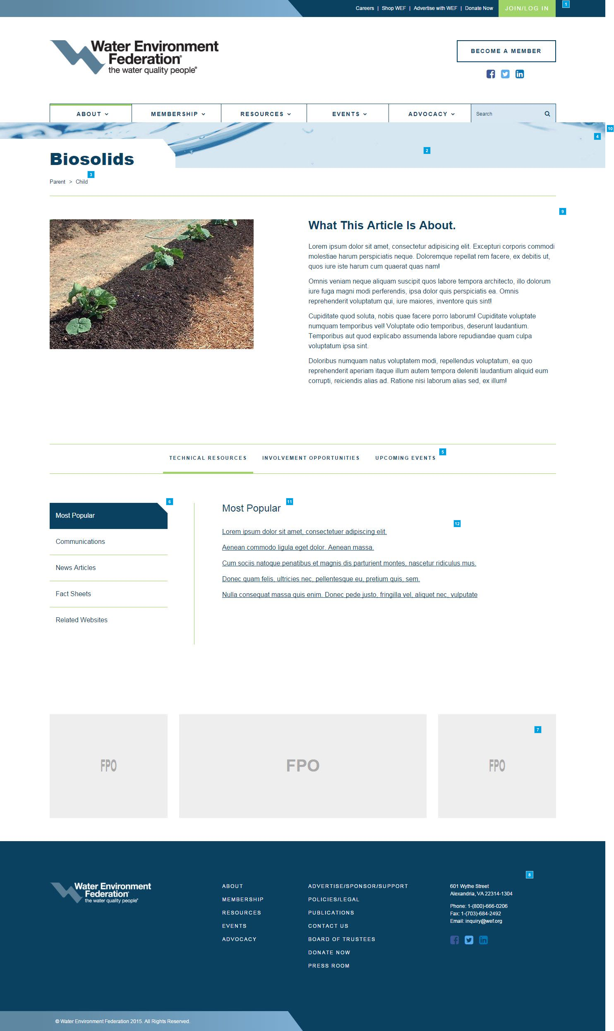

* + 1. Widget Table

|  |  |  |  |
| --- | --- | --- | --- |
| Footnote | Name | Functional Use Case | Implementation Guide |
| 1 | Header and Main Navigation | These elements have the same functionality as indicated in the notes for widgets 1.3.1-8 on the Homepage (Template 1.3). | Please see Implementation Guide for widgets 1.3.1-8 on the Homepage. |
| 2 | Page Headline | Depending on the length of the page title, the white container will expand to the right. | This is to be managed via the topics smart form. |
| 3 | Breadcrumb | Breadcrumb | This is implemented as an Ektron out-of-the-box folder control |
| 4 | Background Image | This image does not need to be managed. It stays fixed with a scrolling parallel effect. The positioning is higher or lower based on the template. Please see mark-up. | Not applicable as this is handled as a front-end development effort. |
| 5 | Content Slider | This will work as a content slider. A user should be able to click on a topic and the content below will fade into place. The maximum number of topics is 6.  An administrator should be able to edit this text. | This is to be managed via the topics smart form.  Please see Implementation Guide for widgets 1.10.8 on the Event - Details page. |
| 6 | Topics Menu | As a user selects a different subject, the Subject Title will highlight and the content to the right will animate in with a simple fade-in.  An administrator should be able to add subjects, remove subjects, reorder subjects and edit the text.  @@ What is the recommended max? @@ | This is to be managed via the topics smart form.  @@ WEF to discuss accordion interaction with Mintium @@ |
| 7 | Ad Deck | @@ WEF to implement using Ban Man Pro @@ | Ban Man Pro script will be the data source which will populate the Ad Sublayout.  The Ad Sublayout is a component of the Homepage Page Layout. |
| 8 | Footer | This element has the same functionality as indicated in the notes for widgets 1.3.45-51 on the Home Page (Template 1.3). | Please see Implementation Guide for widgets 1.3.45-51 on the Homepage. |
| 9 | Subheader | This element has the same functionality as indicated in the notes for widgets 1.9.2-7 on the Leadership page (Template 1.9). | This is to be managed via the topics smart form.  Please see Implementation Guide for widgets 1.9.2-7 on the Leadership page. |
| 10 | Topics Smart Form | The [topics] smart form contains elements used to construct the topics. | ** The following [field name] (and type) are defined within the topics smart form: **  The following fields are contained within the [Main] section: 1) [Page headline] (Text box) 2) [Subheader] (Content selector / Subheader smart form) - Please see Implementation Guide for widgets 1.9.2-7 on the Leadership page.  The following fields are contained within the [Event Slider] section: 3) [Event Slider] (Repeater) - Note that there is a max of six (6) slider headers. Related events is displayed as the last slider. VINCENT - confirm with WEF.   Note: the following fields are contained within the non-upcoming events slider:  4) [Topic] (Repeater)  a) [Topic Menu] - Automatically defined when repeater record entered. Each menu item corresponds to a topic headline entry.  b) [Topic Headline] (Text box)  c) [Topic Copy Text] (Text box)   Note: the following fields are contained within the upcoming events slider:  5) [Event Headline] (Text box)  6) [Event Content Id 1] (Text box)  7) [Event Content Id 2] (Text box)  8) [Event Content Id 3] (Text box)  9) Upcoming Event Date - Automatically defined when event content id selected.  10) Upcoming Event Headline - Automatically defined when event content id selected.  11) Upcoming Event Date and Time - Automatically defined when event content id selected.  12) Upcoming Event Venue, City and State - Automatically defined when event content id selected.  13) Upcoming Event CTA Link - Automatically defined when event content id selected.  14) Upcoming Event CTA Text - An administrator should be not able to edit this text.  Note: Individual UPCOMING events are pulled in from a specified [Event Details] folder. Only UPCOMING events marked as 'Active' are displayed.   The following fields are contained within the [Card] section: 15) [Ad Card] (Text box) - VINCENT - need to ask Tanuj how this will be managed? |
| 11 | Topic Headline | An administrator should be able to edit this text.  Headline's max is 2 lines. | This is to be managed via the topics smart form. |
| 12 | Topic Copy Text | This is considered body copy and should have the capability to use simple WYSIWYG functions on their text.  Styling should be limited to bold, italic, underline, bulleted and numbered lists, etc.  The size of text is determined by type of content.  If using body copy, the text size is 16 pt.  An administrator should be able to edit this text. | This is to be managed via the topics smart form. |